CET: Four Winds Content Player Setup

This document covers process for installing and configuring a [Four Winds](https://www.fourwindsinteractive.com/) digital signage PC that can be managed by CET.

## Operating System Configuration

Currently only the Windows operating system is supported for management from CET. These steps detail best practices for configuring the system for digital signage and prerequisites for the Content Player application.

### Ensure that the PC has all current Windows updates

Start 🡪 Settings 🡪 Update & Security 🡪 Windows Update 🡪 Check for updates

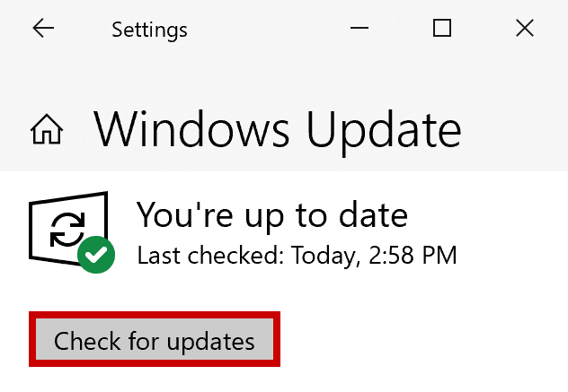

### Install the current display driver for the corresponding PC model

[Intel](https://www.intel.com/content/www/us/en/support/products/80939/graphics-drivers.html), [Nvidia](https://www.nvidia.com/Download/index.aspx), [AMD](https://www.amd.com/en/support)

### Disable Windows system notifications

Start 🡪 Settings 🡪 System 🡪 Notifications & Actions 🡪 DISABLE toggle and checkboxes

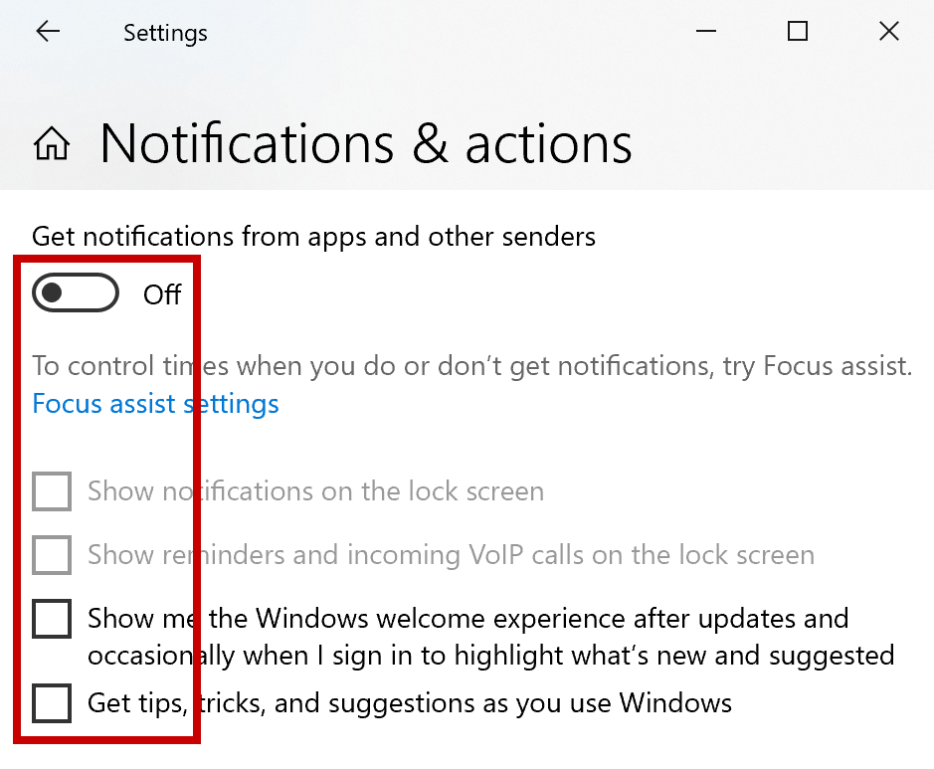

### Open the Four Winds communication port through Windows Firewall (Inbound, TCP, port 10561)

1. Start 🡪 Windows Administrative Tools 🡪 Windows Defender Firewall 🡪 Inbound Rules 🡪 New Rule…

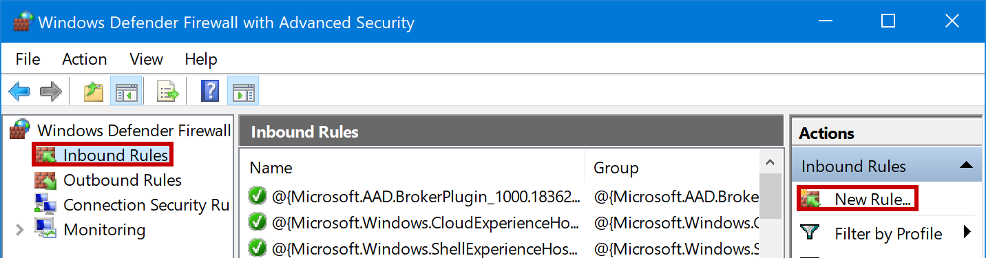

1. CHECK “Port” as the Rule Type

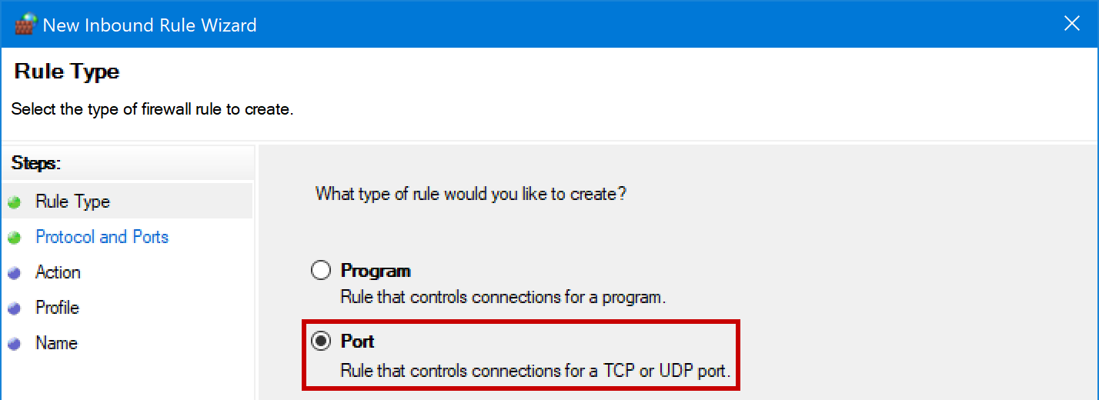

1. CHECK “TCP” as the protocol, and enter **10561** as the specific local port

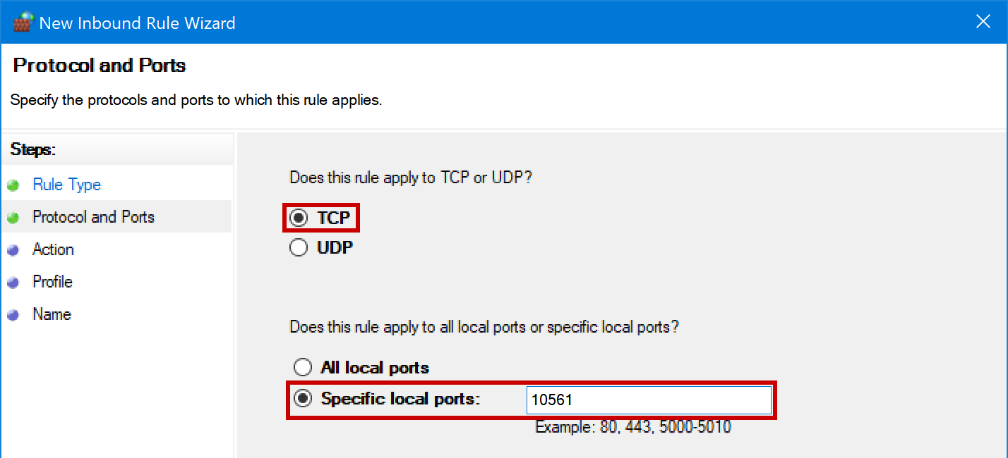

1. CHECK “Allow the connection” to set the appropriate action

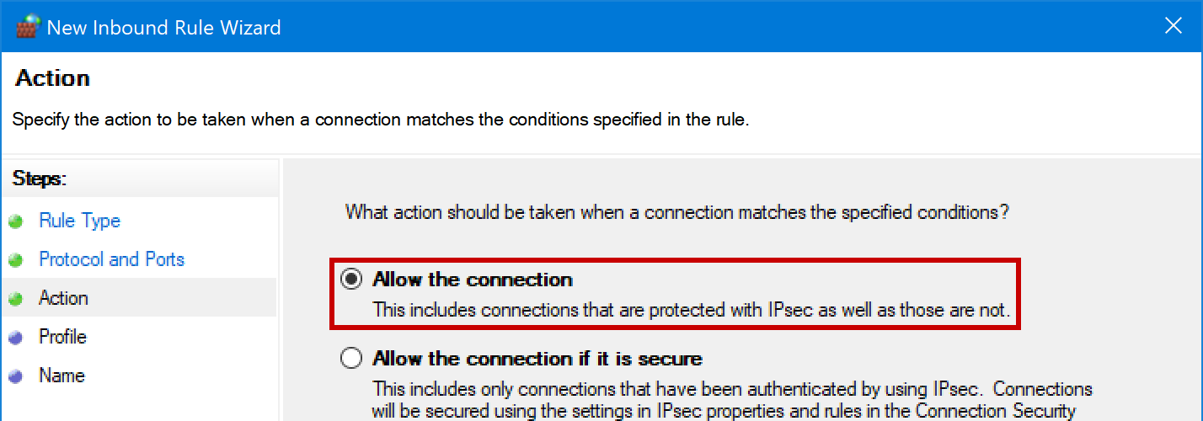

1. CHECK “Domain, Private, and Public” to allow apply this rule to all network types

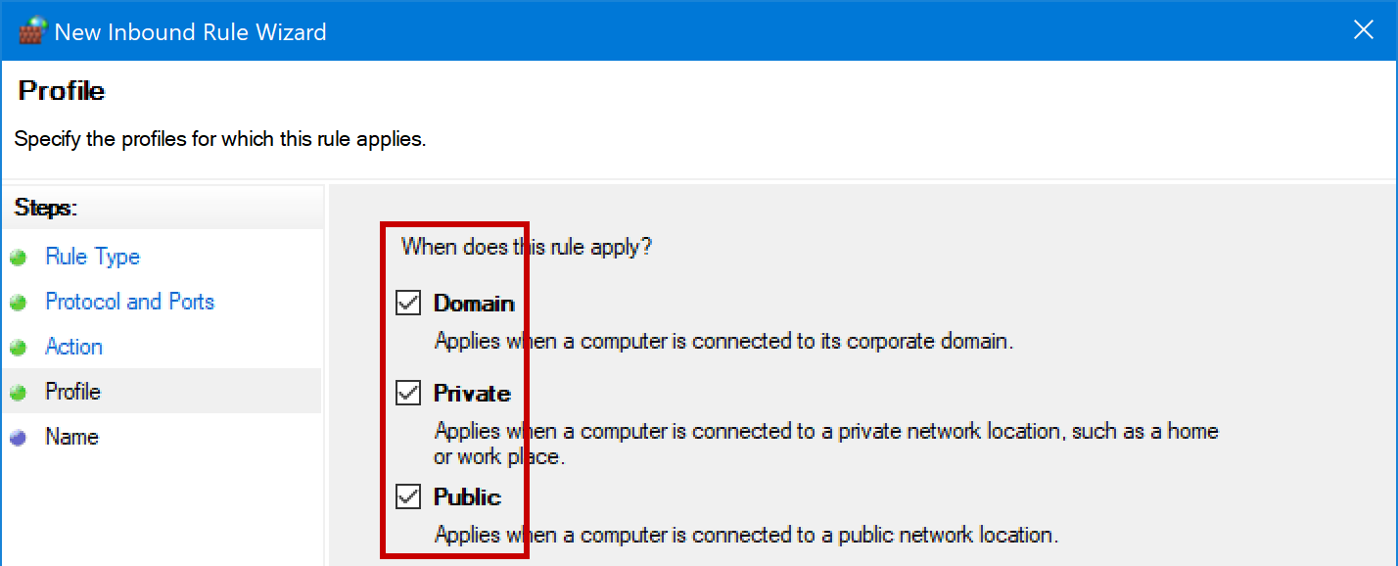

1. Enter “FourWinds” or another corresponding name to identify the rule

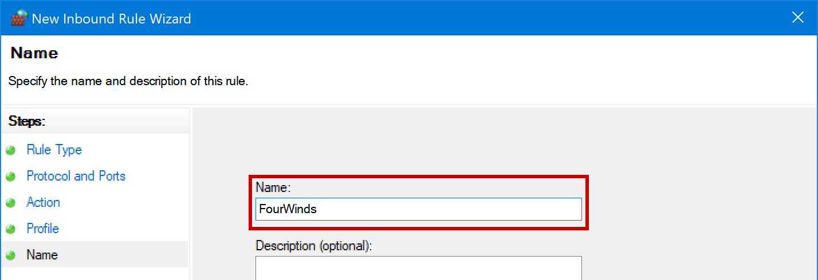

### Set the PC power plan and sleep settings

1. Start 🡪 Settings 🡪 System 🡪 Power & Sleep 🡪 Additional power settings 🡪 Show additional plans 🡪 CHECK "High Performance"

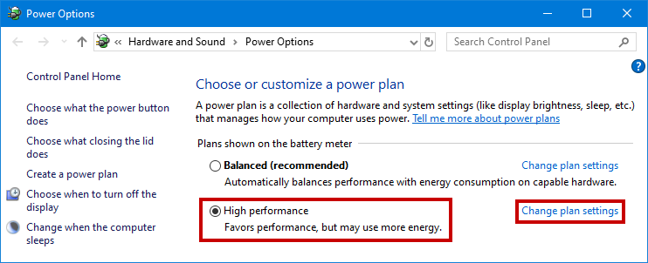

1. Change plan settings 🡪 Set "Turn off the display" to NEVER 🡪 Set "Put the computer to sleep" to NEVER 🡪 Save changes

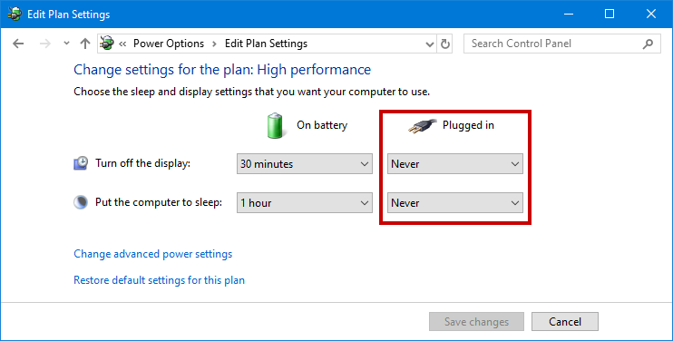

### Unrestrict the PowerShell execution policy (Optional)

Scripts are often utilized for sending commands to and from the Content Player application, as well as launch any external components from within the signage content (browser, application, directory, etc.)

These scripts are often dependent on local execution policy and will not function at the default state.

1. Download the ExecPolicy .zip file [from here](http://ctexp-web01-signage.westus.cloudapp.azure.com/media/files/CET-PlayerInstall/CET-SignagePlayer_ExecPolicy.zip)
2. Extract the .ps1 file from the zip archive

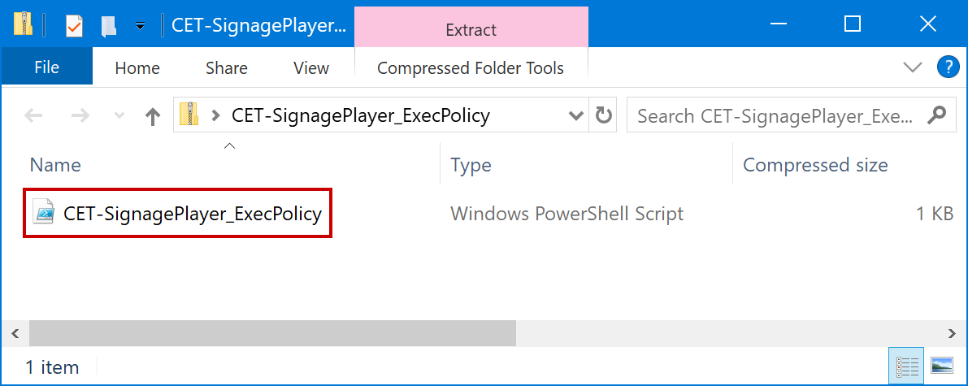

1. Right-click the .ps1 file and select ‘Run with PowerShell’

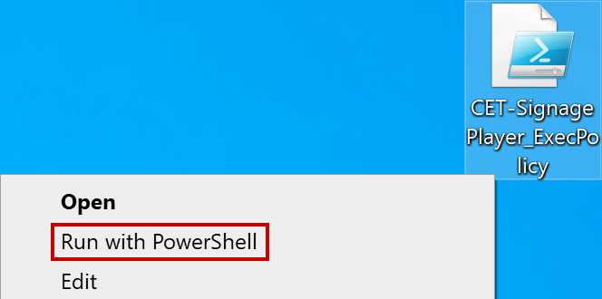

1. Select “Open” from the security prompt

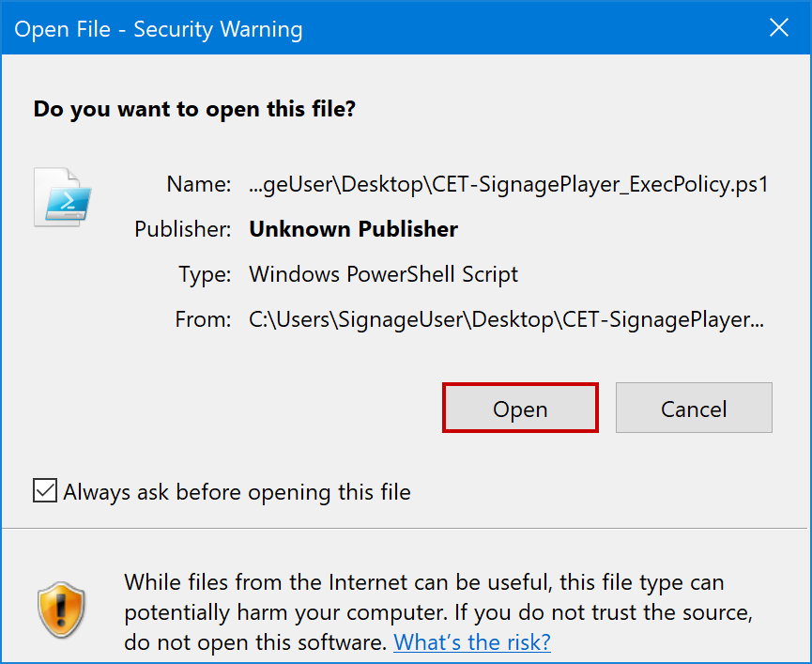

### Configure Auto-Login on the PC (Optional)

The Content Player configuration process includes an automatic nightly reboot for the health and stability of a signage PC. Auto-login allows for the boot process to be automated so that the PC can return to signage display without manual user login each day.

1. Download the AutoLogin .zip file [from here](http://ctexp-web01-signage.westus.cloudapp.azure.com/media/files/CET-PlayerInstall/CET-SignagePlayer_Autologin.zip)
2. Extract the .reg file from the zip archive

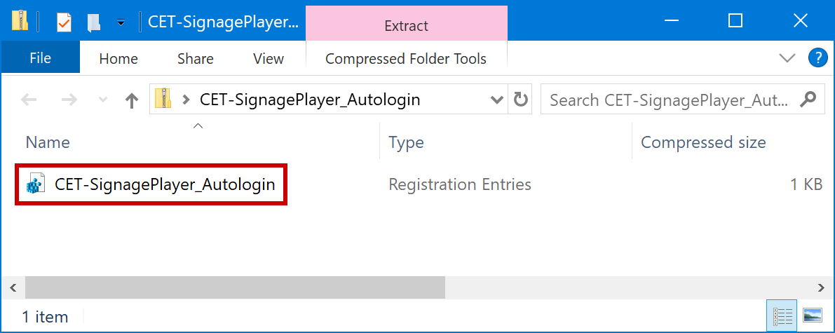

1. Right-click the .reg file and select ‘Edit’

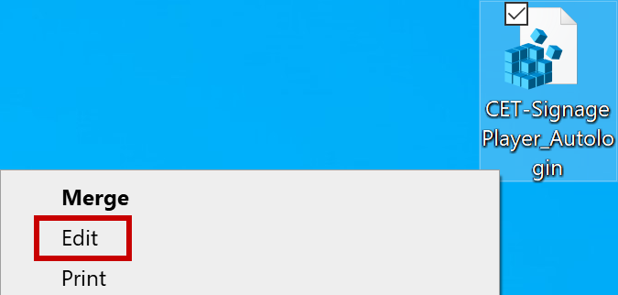

1. Select “Run” from the security prompt

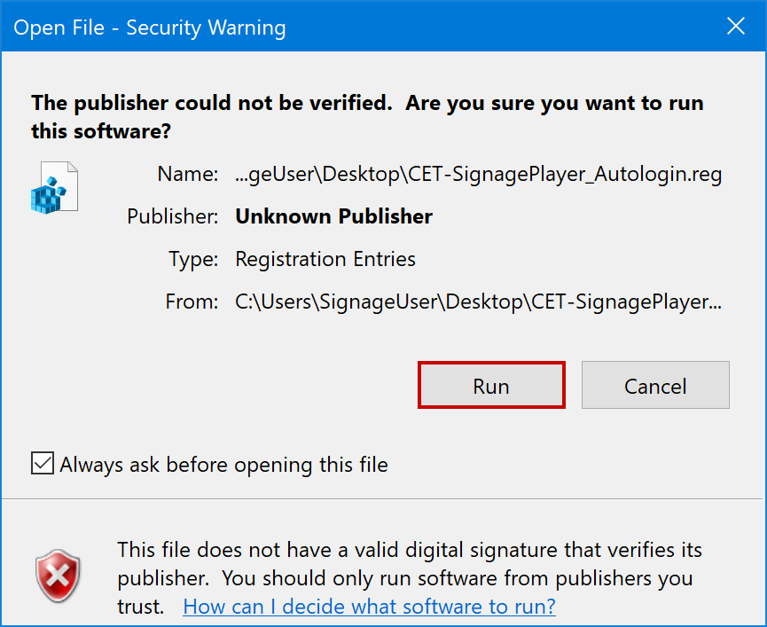

1. Edit the file by replacing USERNAME and PASSWORD with credentials for the intended user account

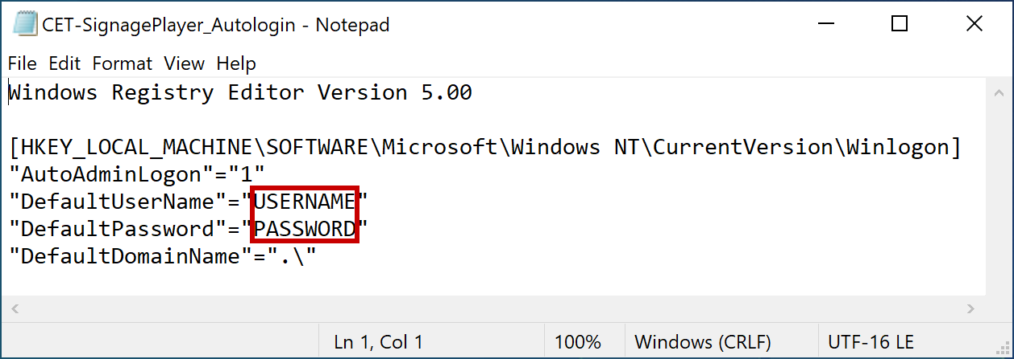

1. Save and close the file
2. Launch the .reg file and select “Run” from the security prompt



1. Select “Yes” at the Registry Editor warning

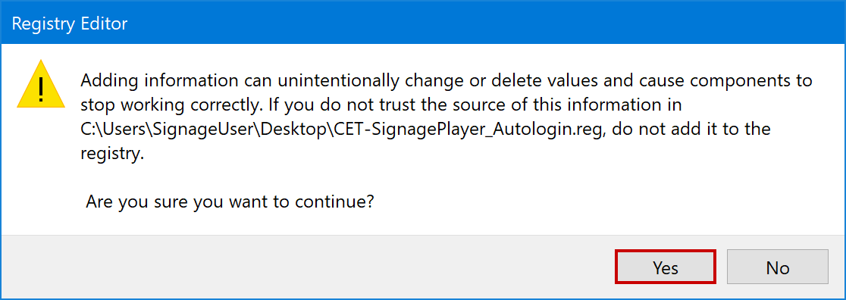

1. Click “OK” at the Registry Editor confirmation window

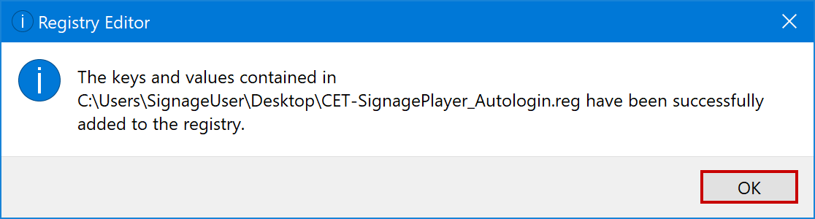

### Disable OS swipe gestures (Optional)

On a touchscreen device it is possible to affect PC settings via the action center by swiping from the right edge of the screen, or to bypass the Content Player application completely by swiping from the left edge of the screen. If intention is to run the signage in a more locked “kiosk” state, then it is recommended to disable these swipe gestures.

1. Download the DisableSwipe .zip file [from here](http://ctexp-web01-signage.westus.cloudapp.azure.com/media/files/CET-PlayerInstall/CET-SignagePlayer_DisableSwipe.zip)
2. Extract the .reg file from the zip archive

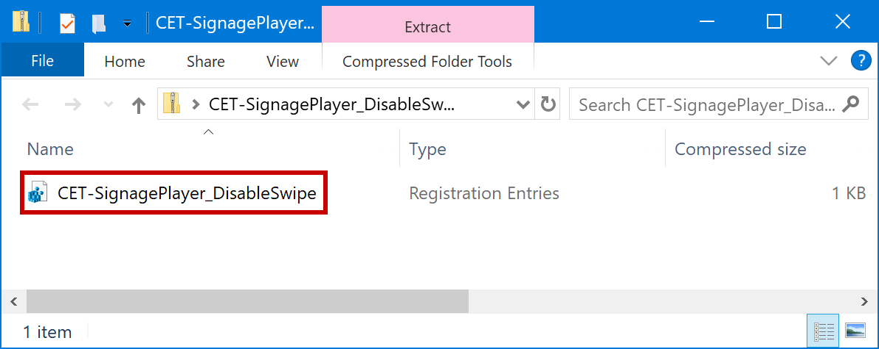

1. Launch the .reg file and select “Run” from the security prompt

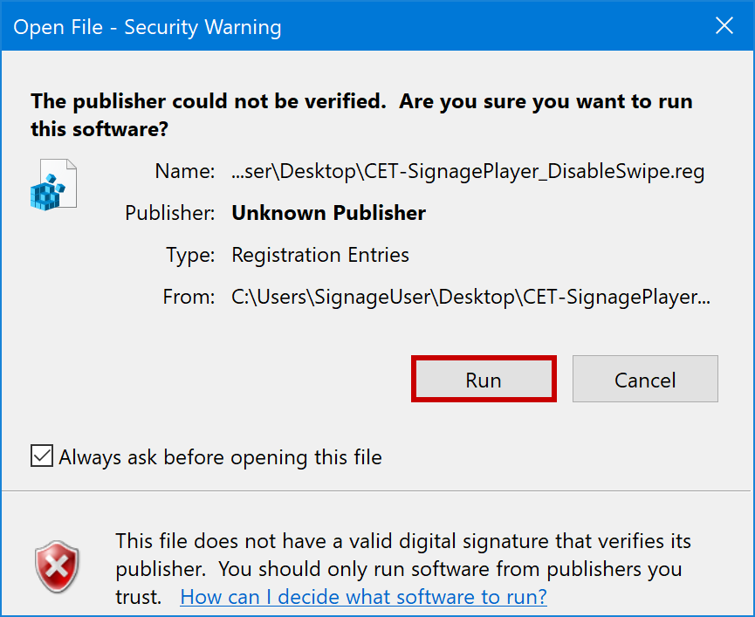

1. Select “Yes” at the Registry Editor warning

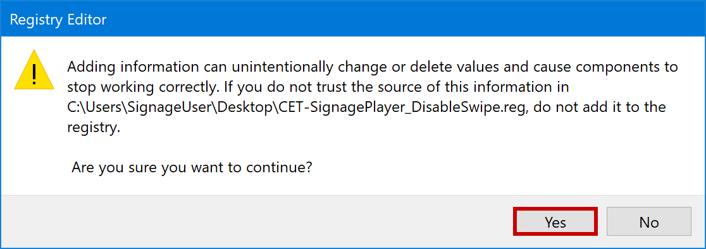

1. Click “OK” at the Registry Editor confirmation window

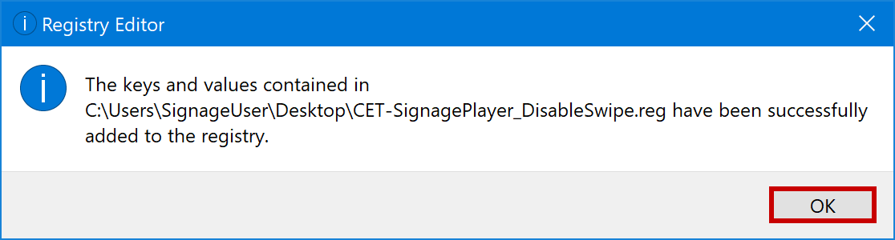

### Restart the PC

## Prerequisite Installations

### Install the LAV Filters package

LAV Filters is a video codec package that enables additional playback features for video content, including expanded format support, hardware acceleration, real-time color keying, and Multicast synchronization.

1. Download the Install .zip file [from here](https://ctexp-web01-signage.westus.cloudapp.azure.com/media/files/CET-PlayerInstall/CET-SignagePlayer_LAVFilters.zip)
2. Extract the .exe file from the zip archive

1. Launch the .exe file and select “Next” at the Destination Location window

1. Continue to select “Next” until you have reached the **Ready to Install** window
2. Select “Install” at the Ready to Install window

1. After installation progress is complete, CHECK “Open LAV Video Configuration” and select “Finish”

1. At the Video Configuration window, under Hardware Acceleration, select “Intel QuickSync”

**NOTE:** If QuickSync is unavailable (indicated by N/A next to the drop-down) select “DXVA2 (copy-back)”

1. Click “Apply”, then click “OK”

## Content Player Configuration

The Four Winds Content Player application is software that enables signage display as well as remote management and monitoring by CET. These steps detail best practices for installing and configuring the application locally.

### Install the Content Player application

1. Download the Install .zip file [from here](http://ctexp-web01-signage.westus.cloudapp.azure.com/media/files/CET-PlayerInstall/FWI-ContentPlayer_Install.zip)
2. Extract the .exe file from the zip archive

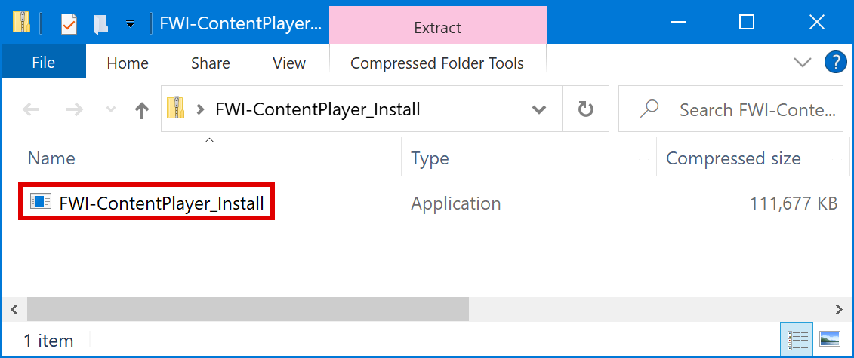

1. Launch the .exe file and select “Install” at the Welcome window

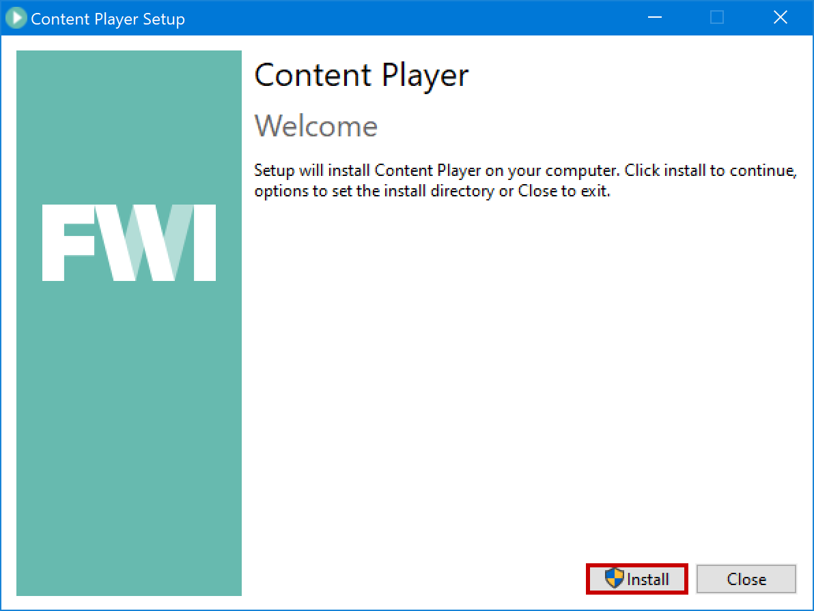

1. Select “Next” at the Setup Wizard window

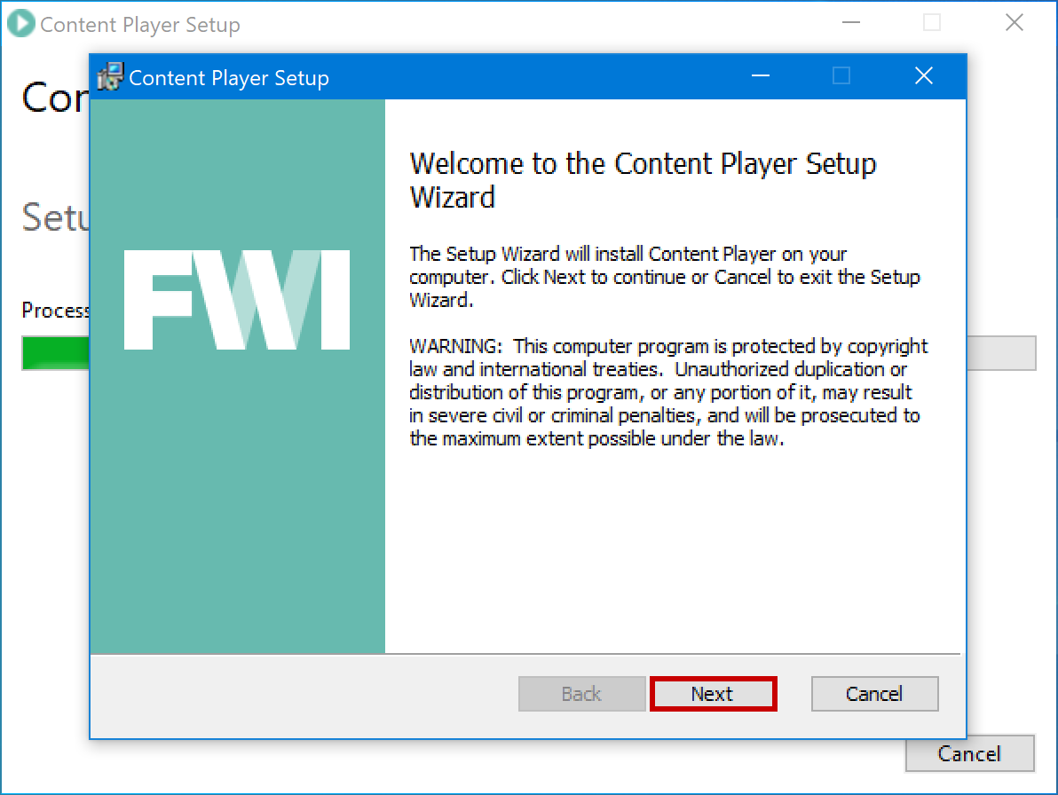

1. Select “Next” at the Destination Folder window

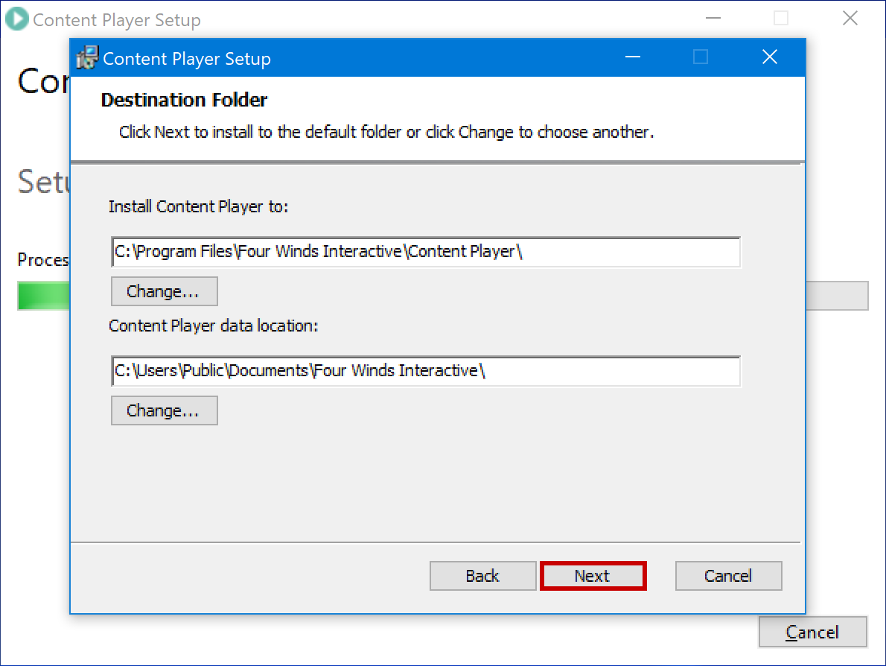

1. Select “Install” at the Ready to Install window

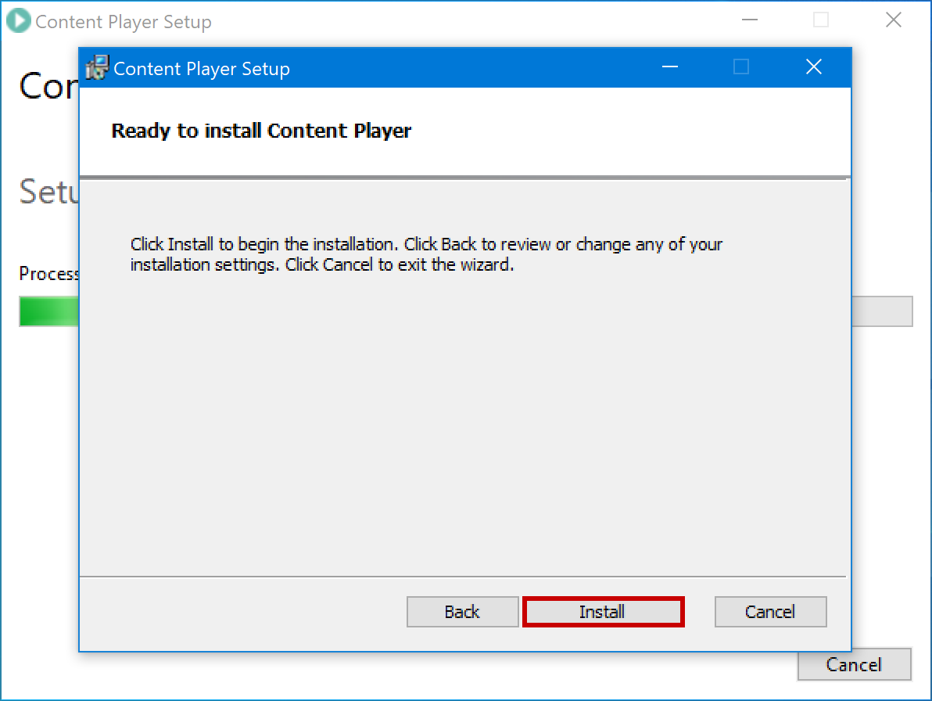

1. Click “Close” at the Setup Successful window

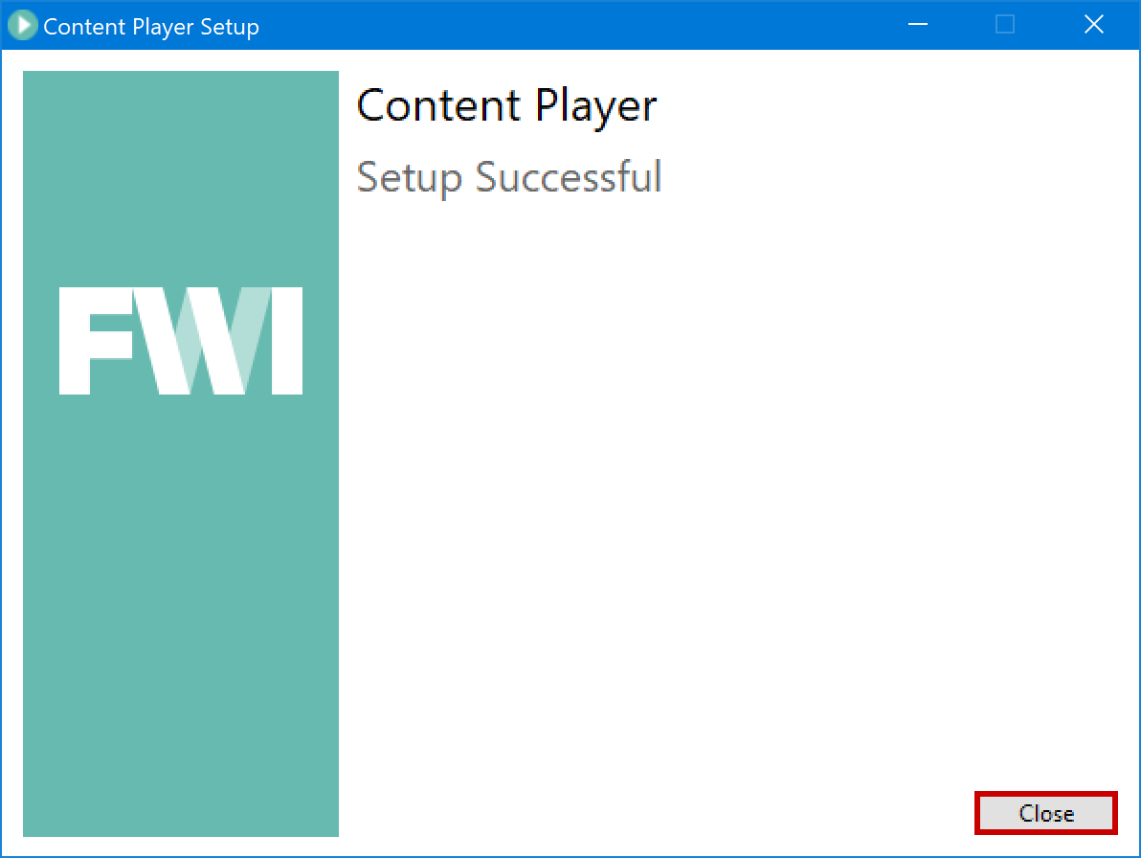

### License the Content Player application

**IMPORTANT:** The application must be licensed in the FourWinds cloud portal to display CET content channels. This is performed by the Redmond Signage Team using system details from the PC. Please follow the steps below to ensure proper registration.

1. Download the PCDetails .zip file [from here](http://ctexp-web01-signage.westus.cloudapp.azure.com/media/files/CET-PlayerInstall/CET-SignagePlayer_PCDetails.zip)
2. Extract the .ps1 file from the zip archive

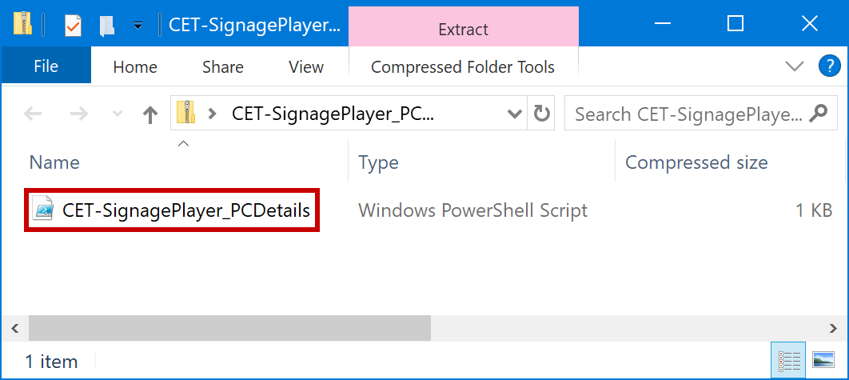

1. Right-click the .ps1 file and select ‘Run with PowerShell’

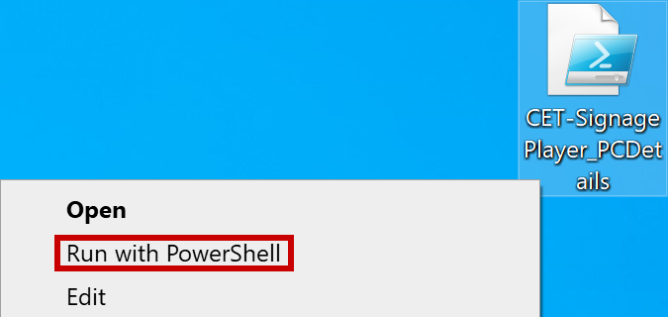

1. Select “Open” at the security prompt

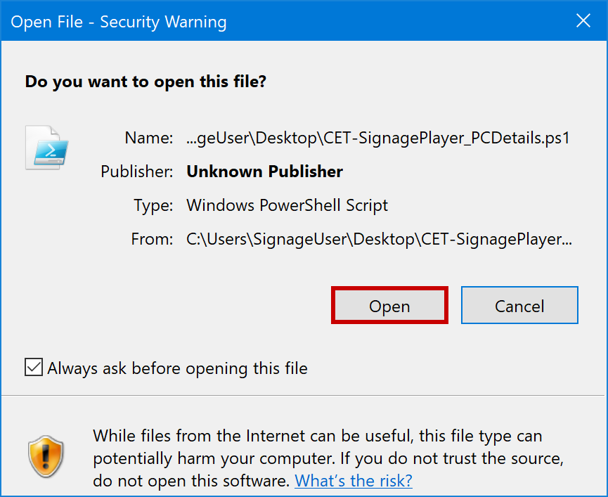

1. Wait for the PowerShell script to complete its operations.

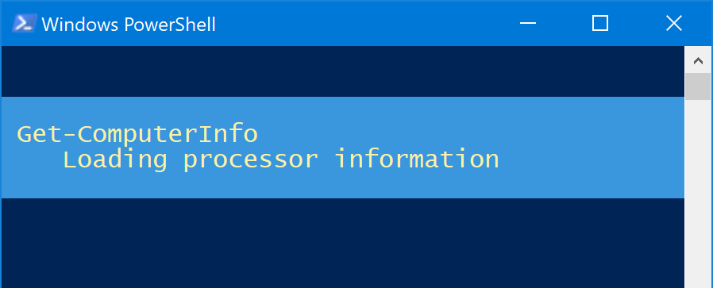

1. An export of the PC details will be placed in a **.csv file on the desktop**. Make a copy of this file and **send to the** [**Redmond Signage Team**](mailto:CETSIGN@microsoft.com) for generation of a Four Winds activation code.

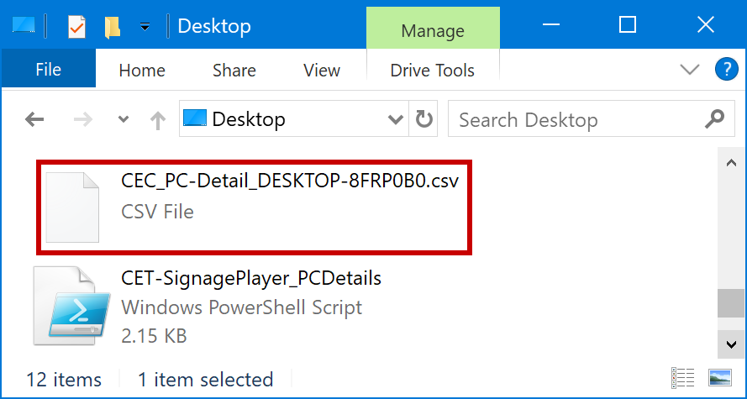

1. Once the Redmond team has replied with the player activation code, enter it into the configuration.
   1. Start 🡪 Four Winds Interactive 🡪 Content Player Configuration

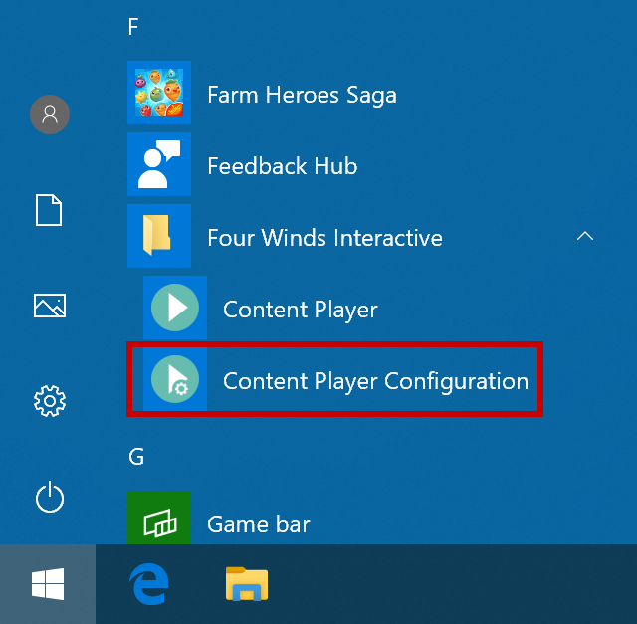

* 1. Navigate to the “About” tab and select ‘Activate Cloud’.

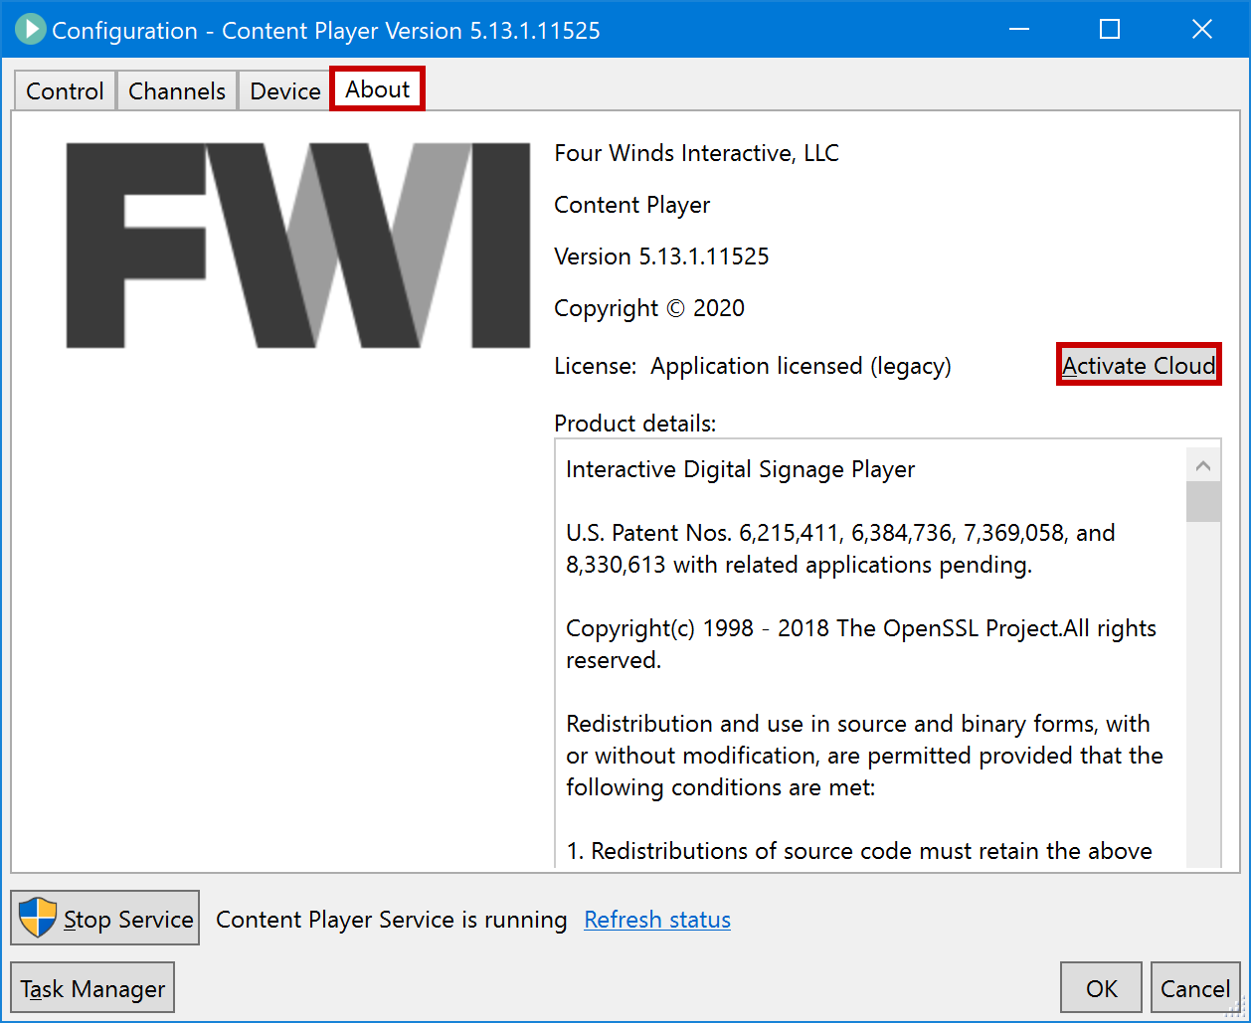

* 1. Type or paste the invite code you received into the box and click “OK”

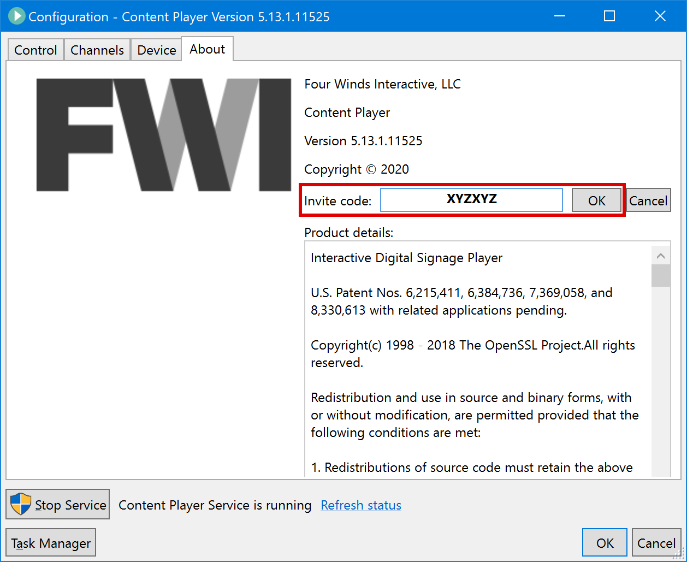

* 1. Wait for the player to complete cloud registration, indicated by a blue message that states, “License successfully activated”. Then click “OK”.

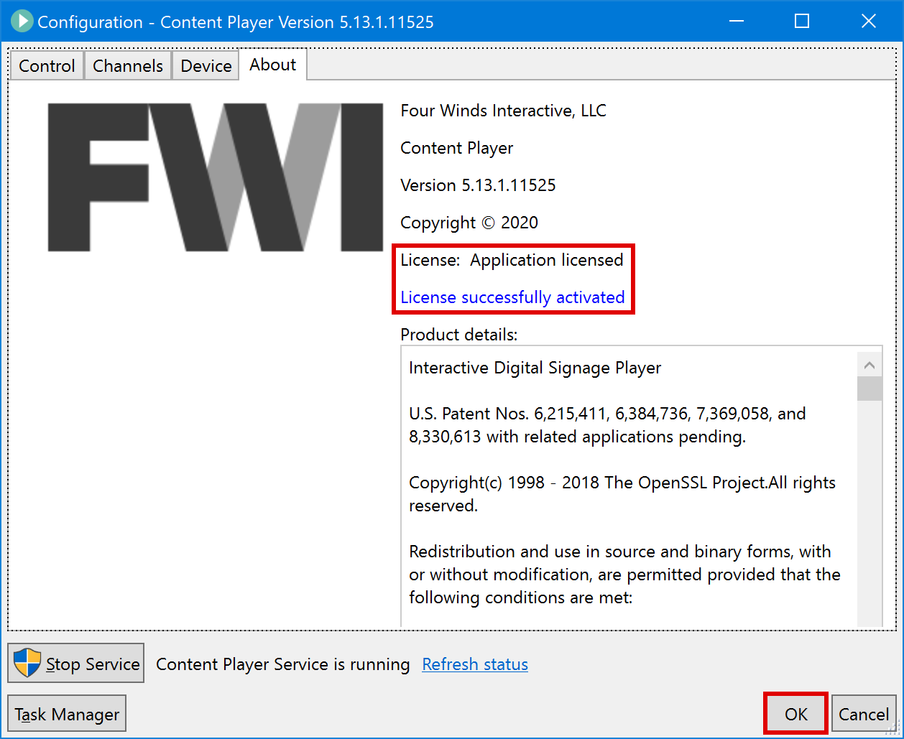

### Configure the Content Player application

1. Start 🡪 Four Winds Interactive 🡪 Content Player Configuration



1. Input these custom configuration settings:

|  |  |  |  |
| --- | --- | --- | --- |
| |  | | --- | | **1.** Navigate to the **Control** tab | | **2.** UNCHECK “Behave as principal application” | |  |
| |  | | --- | | **1.** Navigate to the **Device** tab | | **2.** Set the horizontal, vertical, and swipe touch thresholds to a value of **10** | | **3.** CHECK “Reboot Daily” and set the time to **5:00AM** | | **4.** CHECK “Log screenshot” and set the duration to **00:05:05**. Set the width to **1280** | | **5.** CHECK “Connect to FWI Services” | | **6.** Enter the FWI Services credentials [found here](http://ctexp-web01-signage.westus.cloudapp.azure.com/media/files/CET-PlayerInstall/FWI-ContentPlayer_FWIServices.txt) | | **7.** CHECK “Upload logs daily” | | **8.** Set times to **3:00AM** and **5:00AM** | | **9.** CHECK “Upload status” | | **10.** CHECK “Upload screenshots” | | **11.** CHECK “Use socket for requests” and enter the credentials [found here](http://ctexp-web01-signage.westus.cloudapp.azure.com/media/files/CET-PlayerInstall/FWI-ContentPlayer_SocketRequests.txt) | | **12.** Click “OK” | |  |

### Deploy content to the player

**IMPORTANT:** Remote content deployments are registered server-side based on PC Name. Therefore, prior to completing the steps below you must provide the [Redmond team](mailto:CETSIGN@microsoft.com) with the PC name of the device you are configuring. If you have already sent the PC Details .csv file as part **step 3.1.2** then the device will already be registered and ready for the steps below.

This is a list of current content deployments and their associated IDs:

|  |  |
| --- | --- |
| **Content Package** | **Deployment ID** |
| Microsoft Highlights | CEC-MSH |
| Innovation Showcase | CEC-INNO |
| Microsoft Partner Wall | CEC-PAR |
| Digital Transformation Stories | CEC-DT |
| Digital Transformation #InRealLife | CEC-DTIRL |
| Microsoft AI for Earth | CEC-AI4E |

*For further detail on individual packages please see the CET digital signage* [*content catalog*](https://microsoft.sharepoint.com/:p:/t/CTEXP/EVp2A_k_-RpJnvIiklRwL8UB6Baj899cDy_as6NepzHo8g)

1. Start 🡪 Four Winds Interactive 🡪 Content Player Configuration



1. Input these custom configuration settings:

|  |  |  |  |  |  |  |  |
| --- | --- | --- | --- | --- | --- | --- | --- |
| |  | | --- | | **1.** Navigate to the “Channels” tab | | **2.** CHECK “Retrieve deployment from serv” | | **3.** Enter Deployment ID (see table below) | | **4.** Set the polling interval to **00:30:00** | | **5.** Enter the FWI Services credentials [found here](http://ctexp-web01-signage.westus.cloudapp.azure.com/media/files/CET-PlayerInstall/FWI-ContentPlayer_FWIServices.txt) | | **6.** Click “OK” | |  |

### Set the Content Player application to auto-launch at startup

1. Download the shortcut .zip file [from here](https://ctexp-web01-signage.westus.cloudapp.azure.com/media/files/CET-PlayerInstall/FWI-ContentPlayer_Shortcut.zip).
2. Start 🡪 Windows System 🡪 Run
3. Enter “shell:startup” into the dialog box, then click “OK”

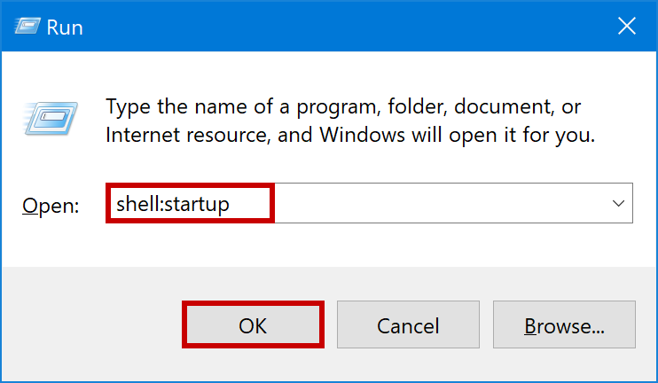

1. Extract the shortcut file to the “Startup” folder.

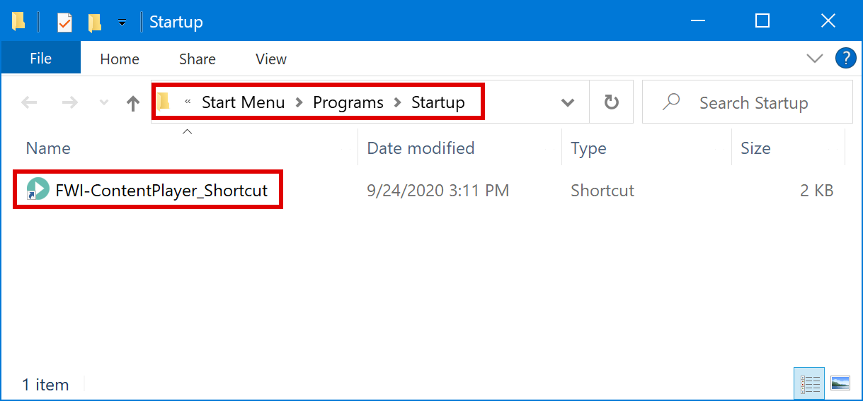

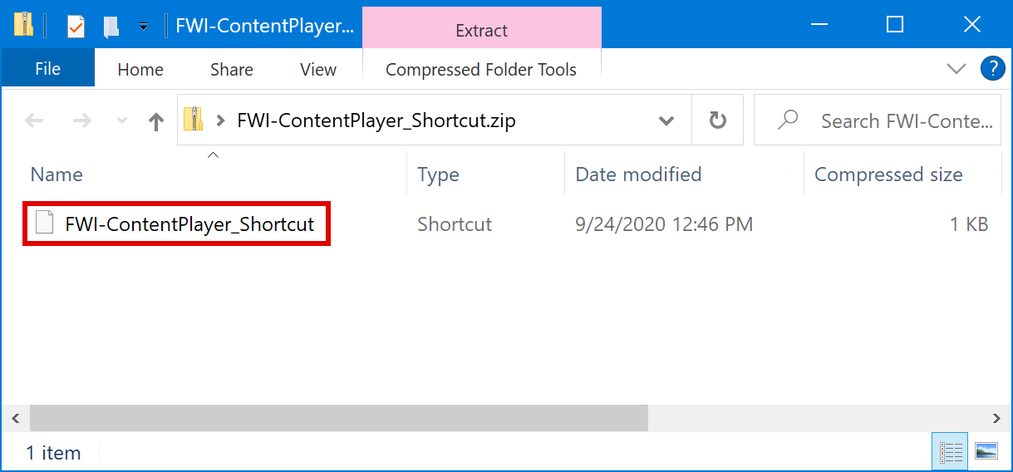

### Restart the PC

## Basic Content Player Operation

Now that the application has been installed, configured, and content is deployed, here are some basic operational items for maintaining 24/7 signage display.

### Launching the Content Player application

1. Start 🡪 Four Winds Interactive 🡪 Content Player

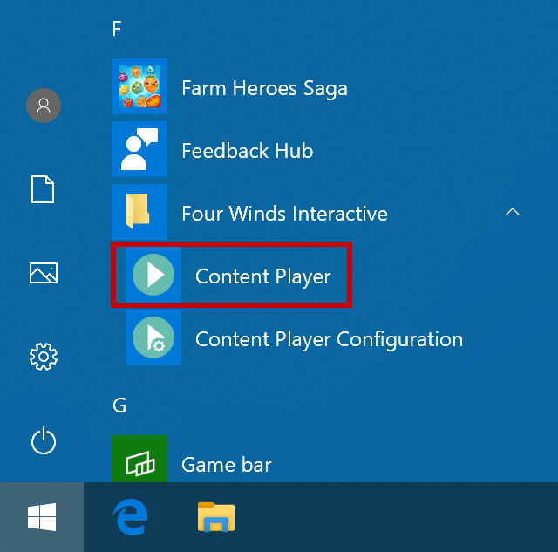

### Closing the Content Player application

Option A

1. Tap/Click the top-left corner of the screen to launch the configuration window
2. Select “Exit Player” from the bottom-left corner of the configuration window

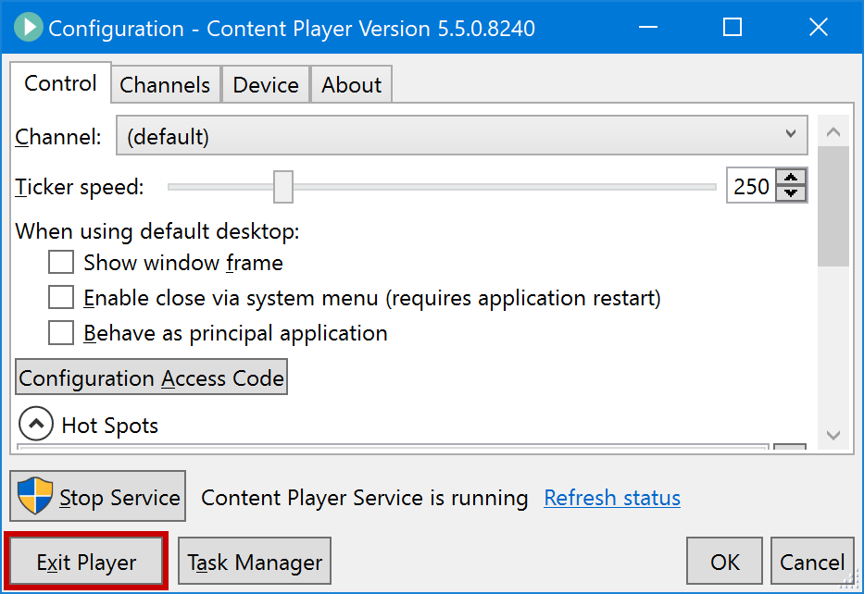

Option B

1. Hit the “Q” key from a keyboard connected to the PC

### Restarting the Content Player service

The Content Player service facilitates deployment updates, monitoring, and reporting features. If these features stop functioning as expected a restart of the service may be required.

1. Start 🡪 Four Winds Interactive 🡪 Content Player Configuration

(If player is running, Tap/Click the top-left corner of the screen to launch the configuration window)



1. Select “Stop Service” from the bottom-left of the configuration window

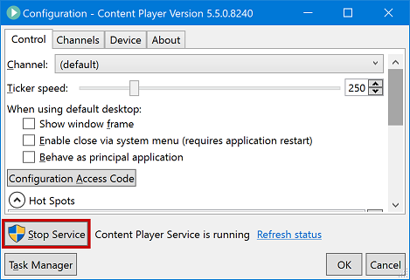

1. Select “Yes” if presented with a UAC Net Command prompt
2. Select “Start Service” from the bottom-left of the configuration window

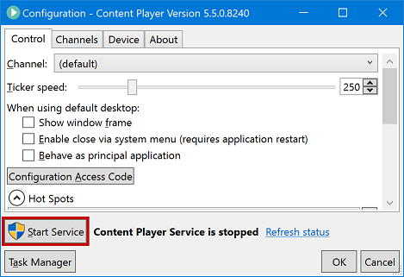

1. Select “Yes” if presented with a UAC Net Command prompt
2. Click “OK” to close the configuration window

### Changing the Content Player deployment

Remote content deployments are assigned server-side based on PC Name. Therefore, prior to completing the steps below you must provide the Redmond team with the PC name and the deployment ID it will be associated with.

1. Start 🡪 Four Winds Interactive 🡪 Content Player Configuration



1. Navigate to the “Channels” tab
2. Enter Deployment ID (see table above)

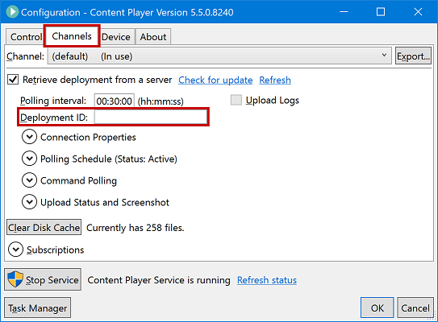

1. Select “Refresh” from the deployment server options

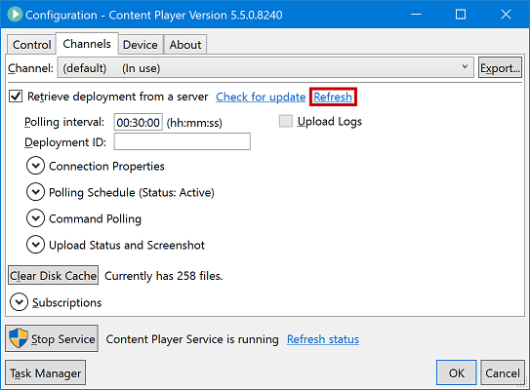

1. Once the deployment has been received click “OK” to close the configuration window

### Clearing the Content Player cache files

The Content Player application creates a local copy of individual assets, allowing them to be displayed without needing to download the content during each occurrence. In some scenarios these cached items may become “stuck” preventing newer versions of the files from being retrieved. In this case the steps below will forcibly clear the cache folder and allow all items to be refreshed from the cloud repository.

1. Close the Content Player application if it is currently running
2. Start 🡪 Four Winds Interactive 🡪 Content Player Configuration



1. Navigate to the “Channels” tab
2. Select “Clear Disk Cache” under the deployment settings

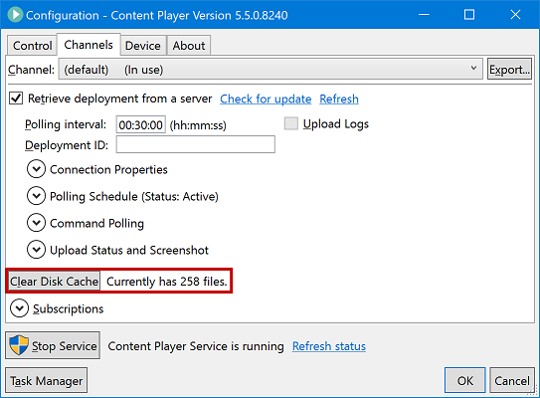

1. Click “OK” at the confirmation prompt

