Customer

Solution

Story

Enable application

innovation

HEINEKEN Uses the Cloud to

Reach 10.5 Million Consumers in

Global Marketing Campaign

“Azure didn’t let us down. More than that, it gave us

a way to assure senior management that we could

support this massive, global campaign.“

Lennart Boorsma, Digital Marketing Manager, HEINEKEN

“Nobody does it better” than secret agent James Bond. So it was natural that when world-class brewer HEINEKEN launched

a global marketing campaign, it would partner with the Bond franchise. And when that campaign needed an equally ﬁrst-

class cloud platform, HEINEKEN turned to Microsoft Azure. HEINEKEN then used Azure for promotions that were even

more technically demanding, including one with the UEFA Champions League. Azure “put our stakeholders at ease,” says an

executive.

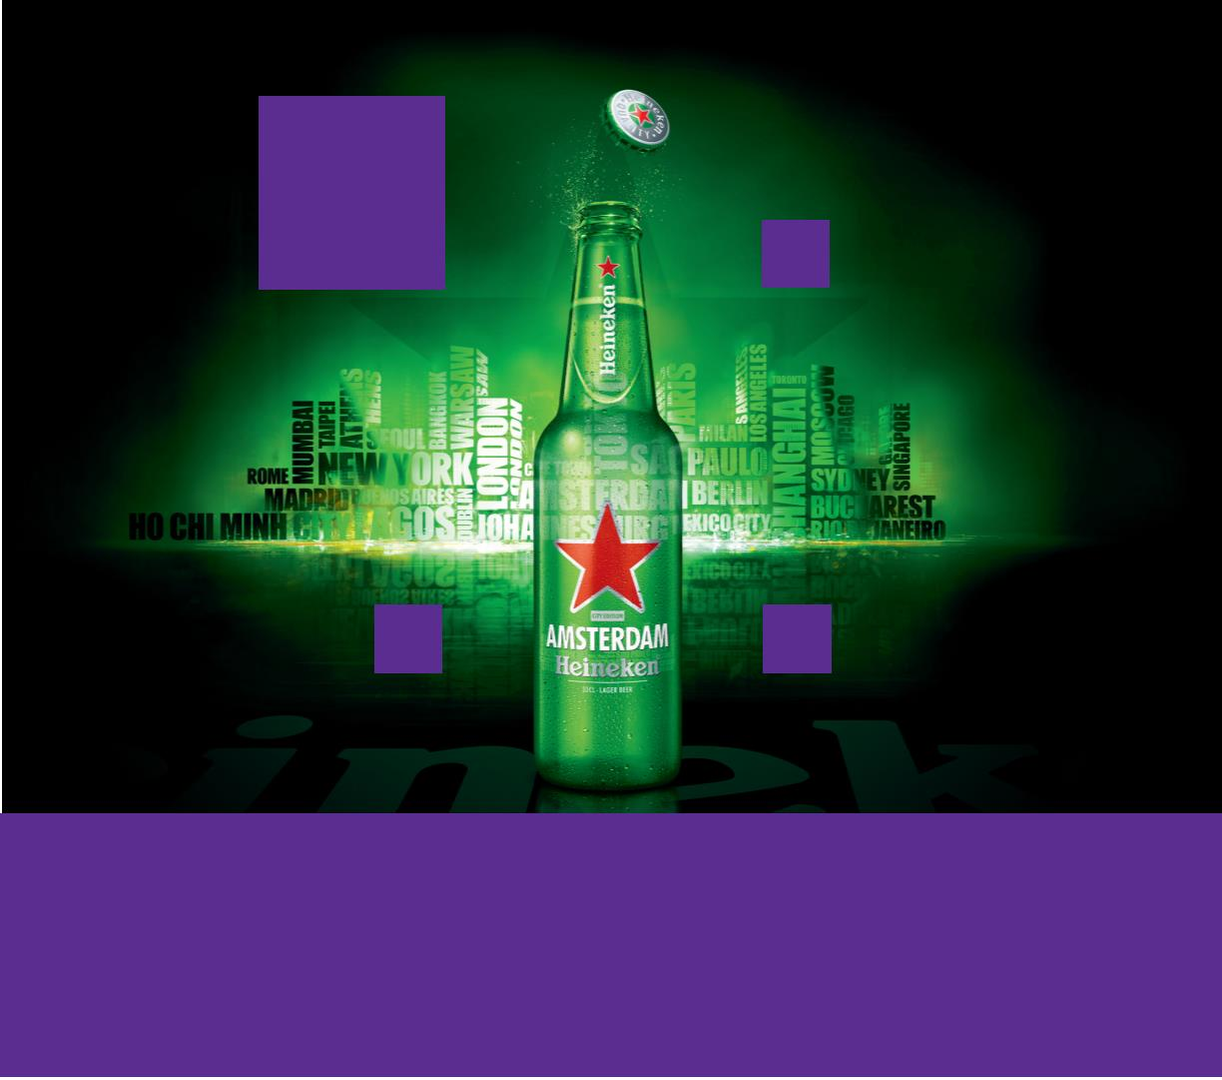ooxWord://word/media/image2.jpegooxWord://word/media/image3.jpegooxWord://word/media/image4.jpeg

Business Needs

primary digital content for the campaign

was a 100-megabyte movie that had to

play ﬂawlessly for millions of viewers

worldwide. After all, Bond never fails. No

one was going to tolerate a technology

failure that might bruise his brand.

When James Bond is on the scene, the fate

of the world often lies in the balance. When

HEINEKEN decided to launch a global

marketing campaign based on the latest

Bond movie, the stakes were also high.

Previously, HEINEKEN had supported digital

media at its outsourced datacenter. But that

datacenter lacked the computing resources

HEINEKEN needed, and building them—

especially to support peak trafﬁc that would

total millions of simultaneous hits—would

have been both time-consuming and

expensive. Nor would it have provided

the geographic reach that HEINEKEN

needed to minimize latency worldwide.

HEINEKEN, which sells its ﬂagship

premium beer in 178 countries, has long

run innovative marketing campaigns

around the world. Along with great beer,

it’s part of what makes Heineken one

of the world’s best-known brands. But

the 2012 campaign, based on the Bond

movie Skyfall, was different than what

HEINEKEN had done before. Traditionally,

its marketing operation had been fairly

decentralized. The campaigns might

have been global, but how they were

implemented was not. Those decisions

had been largely left to the company’s

scores of national and regional marketing

divisions. Rollout dates, for example, were

left to the divisions and, consequently,

global campaigns could be launched

gradually over a period of months.

“We will deﬁnitely continue

to use Azure. We need the

reliability it gives us. We can

also envision using Azure to

avoid the costs of building

and maintaining additional

datacenters around the

world. We could use Azure

as part of a hybrid solution

with our existing resources.

It gives us tremendous

Solution

The cloud was the way to go—but which

cloud? HEINEKEN looked at Amazon Web

Services—and chose Microsoft Azure. “With

Azure, we didn’t have to invest in managing

servers, so we could focus on delivering

the most successful campaign,” says Ewout

Barendregt, Global Center of Excellence

Manager at HEINEKEN. To help deliver that

successful campaign, the company used the

Azure Content Delivery Network to make

the digital content available quickly, reliably,

and globally to 10.5 million consumers.

ﬂexibility.”

Lennart Boorsma, Digital Marketing

Manager, HEINEKEN

But HEINEKEN had been centralizing its

marketing functions for several years. For

the Bond promotion, it planned to launch

the campaign at the same time everywhere

on the planet. That created unprecedented

challenges for HEINEKEN—nowhere more

so than in its technology operation. The

The next year, HEINEKEN faced a digital

marketing challenge that was in some ways

even greater. This time, HEINEKEN based

Overview

Customer Proﬁle

Customer: HEINEKEN

Based in Amsterdam, HEINEKEN is the number

1 brewer in Europe and the number 2 brewer by

volume in the world.

Customer Website: www.HEINEKEN.com

Customer Size: 85,000 employees

Country or Region: The Netherlands

Industry: Manufacturing—Consumer goods

ooxWord://word/media/image6.jpegooxWord://word/media/image7.jpegooxWord://word/media/image8.jpegooxWord://word/media/image9.jpeg

a global campaign on UEFA Champions

League (UCL) soccer games. The campaign

would launch simultaneously in more

than 70 markets and 30 languages.

But although the Skyfall campaign

had “merely” required the company to

host a giant website to serve content,

the UCL campaign would require real-

time computing on a global scale.

yet another way, for its Open Your City

campaign. In this campaign, consumers

interact with HEINEKEN through Twitter

and other social media to get suggestions

on “socially hot” clubs and bars located

near them at any given moment.

“Given the success of these campaigns, we

now use Microsoft cloud services beyond

marketing,” says Boorsma, citing Microsoft

Dynamics CRM Online for customer

relationship management and Ofﬁce 365

for increased employee productivity.

“Latency is something that

players shouldn’t even have

to think about. Thanks to

Azure, it wasn’t an issue.

That was an important

That’s because the centerpiece of the

UCL campaign was a pinball game for

consumers to play live against players

anywhere in the world. The solution

would also have to support multiple

leaderboards for each player, based on

the number of friends and family that an

individual played with. It would require

real-time updating of the leaderboards

as play was underway. HEINEKEN wanted

the technology to support 1 million

simultaneous users. And, in the words

of Lennart Boorsma, Digital Marketing

Manager at HEINEKEN, “It couldn’t fail.”

Beneﬁts

HEINEKEN has used Azure in three

global campaigns, supporting millions of

users, minimizing latency, and laying the

foundation for signiﬁcant cost savings.

factor keeping people on the

site and in the game.”

Scales to 2 Million Gameplays per Hour

HEINEKEN used Microsoft Azure to achieve

100 percent reliability on a massive scale.

The platform exceeded its service-level

agreement with perfect performance in

the UCL campaign, supporting 2 million

gameplays per hour and with capacity

for more than 40 million players in all.

Lennart Boorsma, Digital Marketing

Manager, HEINEKEN

To meet these requirements, HEINEKEN

expanded its use of Azure from one

datacenter to four—one each in Europe

and Asia, and two in the US—gaining

geo-redundancy and low latency. Data

was stored in Azure Table Storage for

asynchronous updates. The storage was

structured with 10,000 partitions—up from

10 initially—for the requisite scalability.

HEINEKEN developed the solution

using Microsoft Visual Studio 2013. The

architecture was tested with a Visual Studio

load-testing cluster to generate the load

and test the application without testing

the Internet. Microsoft Services consultants

helped develop and load-test the solution,

and resolve performance issues.

“Azure didn’t let us down,” says Boorsma.

“More than that, it gave us a way to

assure senior management that we could

support this massive, global campaign.

It put our stakeholders at ease, knowing

that we had them covered. When you

bring out a global campaign with such

bravura, you really do need to make sure

that all your homework is done. With

Azure, it was. Thank you, Microsoft.”

Delivers Latency of 200–300 Milliseconds

HEINEKEN also met its requirements for

low latency worldwide with Azure. Latency

rates ranged from 7 milliseconds to 535

milliseconds, with typical rates clustering

The results of this solution (see below)

led HEINEKEN to use Azure again, in

ooxWord://word/media/image12.jpegooxWord://word/media/image13.jpegooxWord://word/media/image14.jpeg

between 200 and 300 milliseconds. That

was a tremendous beneﬁt for global, real-

time game-playing. As a result, players

enjoyed their experiences and continued

playing for an average of 4.5 minutes.

For example, Azure could play a role

in the company’s website upgrade.

“We will deﬁnitely continue to use Azure,”

says Boorsma. “We need the reliability

it gives us. We can also envision using

Azure to avoid the costs of building and

maintaining additional datacenters around

the world. We could use Azure as part of a

hybrid solution with our existing resources.

It gives us tremendous ﬂexibility.”

“Latency is something that players

shouldn’t even have to think about,”

says Barendregt. “Thanks to Azure, it

wasn’t an issue. That was an important

factor keeping people on the site and in

the game. When you consider we had

5.2 million players during the run of the

campaign, that comes to 55 years of

brand engagement—an insane number.”

Microsoft customer successes, please visit:

www.microsoft.com/customers

Provides Reliability, Savings, Flexibility

Boorsma expects that HEINEKEN will

make more use of Azure, both for

marketing campaigns and other purposes.

Software and Services

Microsoft Azure platform

Microsoft Dynamics

• Microsoft Dynamics CRM Online

Microsoft Ofﬁce

Microsoft Visual Studio 2013

•

Microsoft Azure Content Delivery

Network

•

Microsoft Ofﬁce 365

•

•

•

•

•

•

Microsoft Azure SQL Database

Microsoft Azure Table Storage

Microsoft Azure Trafﬁc Manager

Microsoft Azure Virtual Machines

Microsoft Azure Websites

Microsoft Cloud Services

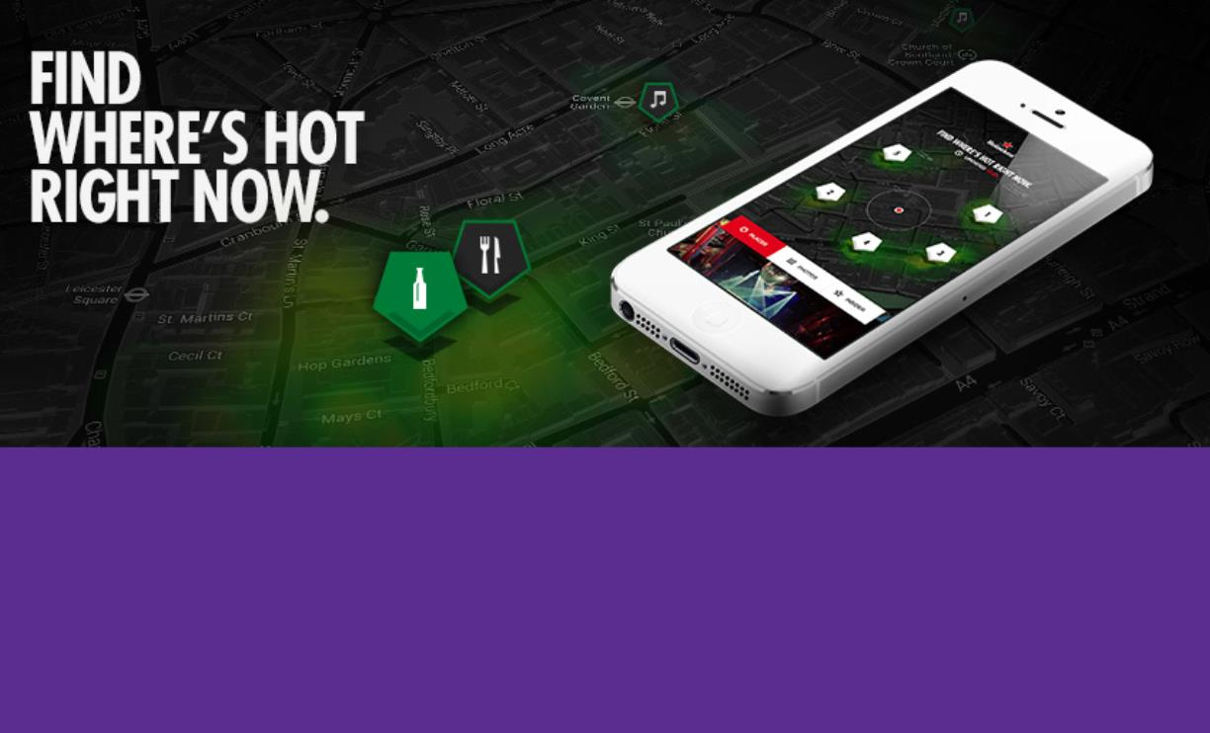ooxWord://word/media/image16.jpegooxWord://word/media/image17.jpegooxWord://word/media/image18.jpeg