Customer

Solution

Story

Unlock insights

on any data

A UK Bank Looks for BI that’s as

Fast, Friendly, and Reliable as the

Bank Itself—and Finds Power BI

“We go live with mobile banking and in less than a

week we have a full business intelligence suite to track

it. It’s pretty cool. Power BI was instrumental in this.”

Bruce Rioch,

Head of Business Information and Customer Systems, Metro Bank

You do something that no one else has done in more than 100 years. You base your business on delighting your

customers like no one else in the market. You’re a startup, so you can run your operation on any technology you choose.

What do you do now?

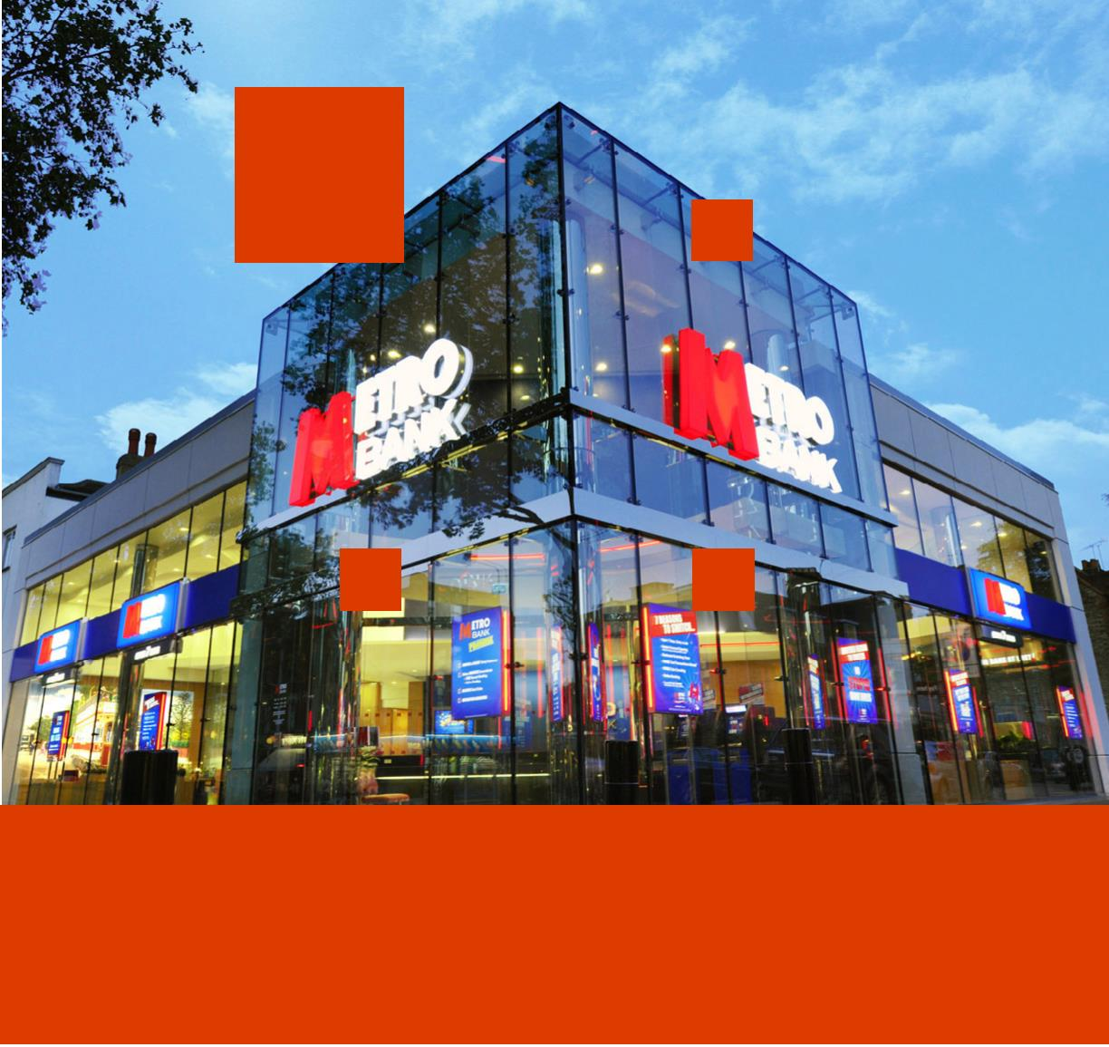ooxWord://word/media/image2.jpegooxWord://word/media/image3.jpegooxWord://word/media/image4.jpeg

You might not think that London, long

one of the world’s ﬁnancial capitals,

needed another bank. Indeed, no one

had tried to start a retail bank there—

what the British call a “High Street”

bank—in more than 100 years.

water bowls to refresh their dogs.

That’s turned out to be a winning

proposition. After four years, Metro Bank

now has more than 350,000 customer

accounts. And the bank doesn’t plan to

stop growing any time soon; it has its

sights on 1 million customers by 2020.

“We set out to create

fans, not customers.

Until 2010.

As the bank has continued to grow,

it’s become increasingly important to

understand how its customers interact

with all its services, including stores,

online, telephony, and mobile. Analyzing

this information will help Metro Bank

to ﬁne-tune its services and reach its

million-customer goal. The company

needed a business intelligence (BI)

solution that could quickly and accurately

provide this information and analysis.

That’s when Metro Bank went into business.

Metro Bank prides itself on being different.

It is, and that difference is evident even

before one enters a store. Big and bright,

with all-glass exteriors and glowing logos,

the bank’s “stores” look like they could

be selling consumer electronics rather

than consumer banking services. That

impression is intentional. It signals the

unrelenting focus on customer service

that the bank is betting its business on.

That’s our proposition.

We want to surprise

and delight. We want

to be the bank that our

customers tell their family

and friends about—the

bank that offers amazing

customer service and has

a simple, understandable

proposition.”

A Fortunate Delay

“We set out to create fans, not customers,”

says Bruce Rioch, Head of Business

In 2012, Metro Bank was about to purchase

a business intelligence system from a

third-party company that would run

from the back-ofﬁce computers to the

desktops of bank colleagues. But they

didn’t. “We were implementing a customer

relationship management system and

other technologies from Microsoft, and

we thought doing the BI system at the

same time would be too much,” says

Rioch. It was a fortunate delay, because

it gave Metro Bank time to discover the

Microsoft business intelligence solution—

Microsoft Power BI for Ofﬁce 365.

Bruce Rioch,

Head of Business Information and

Customer Systems, Metro Bank

Information and Customer Systems at

Metro Bank. “That’s our proposition. We

want to surprise and delight. We want to

be the bank that our customers tell their

family and friends about—the bank that

offers amazing customer service and has

a simple, understandable proposition.”

Refreshing the Dogs

Putting that proposition into practice

means opening accounts and issuing

debit cards to new customers within

minutes. It means round-the-clock

call-center service with people, not

machines, answering the phones, and

stores that stay open seven days a

week. It even means outﬁtting stores

with “Magic Money Machines” to count

coins for customers and entertain

their kids, and providing treats and

“Power BI was going to be faster and

easier to use,” says Rioch So, just as

Metro Bank had adopted Microsoft

Dynamics CRM Online after considering

other alternatives, it now chose

Microsoft for business intelligence.

Overview

Customer Proﬁle

Customer: Metro Bank

Customer Website: metrobankonline.co.uk

Customer Size: 1,400 colleagues

Country or Region: United Kingdom

Industry: Financial services—Banking

Metro Bank, the ﬁrst new “High Street” bank in

more than a century, has 27 stores and more than

350,000 customer accounts

ooxWord://word/media/image7.jpegooxWord://word/media/image8.jpegooxWord://word/media/image9.jpegooxWord://word/media/image10.jpeg

He Got What He Wanted

Rioch wanted simple and fast. And he got

it. For example, in the bank’s run-up to the

release of its mobile-banking service, the

mobile-banking team knew it would want

to track BI in order to understand how

customers were interacting with the app.

Getting the right information is part of the

BI challenge. Getting it to the right people

is the other. Rioch likes how executives

and colleagues can view and collaborate

on BI data with Power BI. He points to

a natural-language Q&A feature that

colleagues can use to get information

from Power BI even if they’ve never used

a business intelligence system before.

Power BI provided an easy way to do

so. The bank launched mobile banking

on a Tuesday. On Thursday, the team

gathered the ﬁrst data on how customers

were using it. On Friday, it used Power

BI tools to clean up and sift through

the data. Over the weekend, the team

spent two hours creating a Power BI

dashboard to give executives and

colleagues highly visual, at-a-glance

statistics on how many people were using

it to make payments, view balances and

transactions, ﬁnd a nearby branch, and

perform about 20 other functions.

Watching People’s Faces

“It’s my favorite bit,” Rioch says of the

feature. “I like to watch people’s faces

when they see how easy it is to get

information that hasn’t already been

published.” Power BI is so simple and

visually appealing that he expects the

bank to roll it out to all colleagues.

Bank colleagues get a 45-minute online

introduction to Power BI. That’s it. When

they have questions, they go to the

same place they go to share Power BI

data: an enterprise social collaboration

group powered by Yammer, another

part of the bank’s Microsoft solution.

Metro Bank also uses the Windows 8.1

operating system, Microsoft SharePoint

Online for knowledge management, and

Microsoft Lync Online for presence, instant

messaging, and web conferencing.

Simple, fast, friendly, and reliable. It’s

how Metro Bank runs its business.

“It’s Pretty Cool”

“That’s what I mean by simple and

fast,” says Rioch with a smile. “We go

live with mobile banking and in less

than a week we have a full business

intelligence suite to track it. It’s pretty

cool. Power BI was instrumental in this.”

Metro Bank has had a year to put Power

BI through its paces, creating a variety of

dashboards to track bank operations. It uses

Power BI to drive millions of transactions

into balance sheets and proﬁt-and-loss

statements, “making the lives of our

It’s also what the bank thinks of the

technology it gets from Microsoft.

For more information about other

Microsoft Customer Successes, please

visit: www.microsoft.com/casestudies

ﬁnance team really easy,” says Rioch.

Software and Services

•

Microsoft Ofﬁce 365

Microsoft Lync Online

Microsoft Power BI for Ofﬁce 365

Microsoft SharePoint Online

•

Microsoft Dynamics

Microsoft Dynamics CRM

•

•

Windows 8.1

Yammer

◦

◦

◦

◦

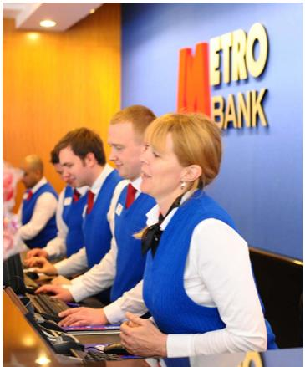ooxWord://word/media/image12.jpegooxWord://word/media/image13.jpegooxWord://word/media/image14.jpegooxWord://word/media/image15.jpeg