CET: Four Winds Content Manager Setup

This document covers process for installing and configuring the [Four Winds](https://www.fourwindsinteractive.com/) management software that can be used to create digital signage within the existing CET environment.

## Operating System Configuration

Currently only the Windows operating system is supported for connecting to the CET environment. These steps detail best practices for configuring the system for signage creation and prerequisites for the Content Manager application.

### Ensure that the PC has all current Windows updates

Start à Settings à Update & Security à Windows Update à Check for updates

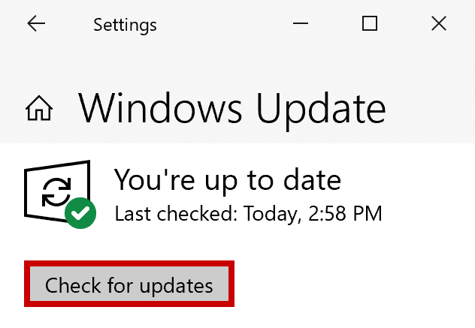

### Install the current display driver for the corresponding PC model

[Intel](https://www.intel.com/content/www/us/en/support/products/80939/graphics-drivers.html), [Nvidia](https://www.nvidia.com/Download/index.aspx), [AMD](https://www.amd.com/en/support)

### Unrestrict the PowerShell execution policy (Optional)

Scripts are utilized for sending commands to the Content Player application, as well as to launch any external components from within the signage content (browser, application, directory, etc.)

These scripts are often dependent on local execution policy and will not function at the default state.

1. Download the ExecPolicy .zip file [from here](https://ctexp-web01-signage.westus.cloudapp.azure.com/media/files/CET-PlayerInstall/CET-SignagePlayer_ExecPolicy.zip)
2. Extract the .ps1 file from the zip archive

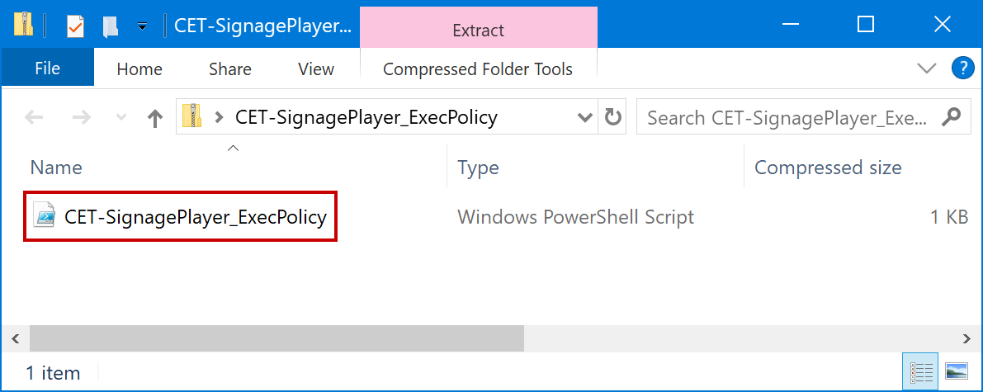

1. Right-click the .ps1 file and select ‘Run with PowerShell’

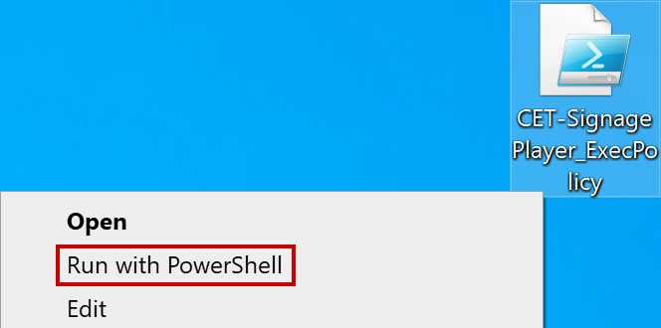

1. Select “Open” from the security prompt

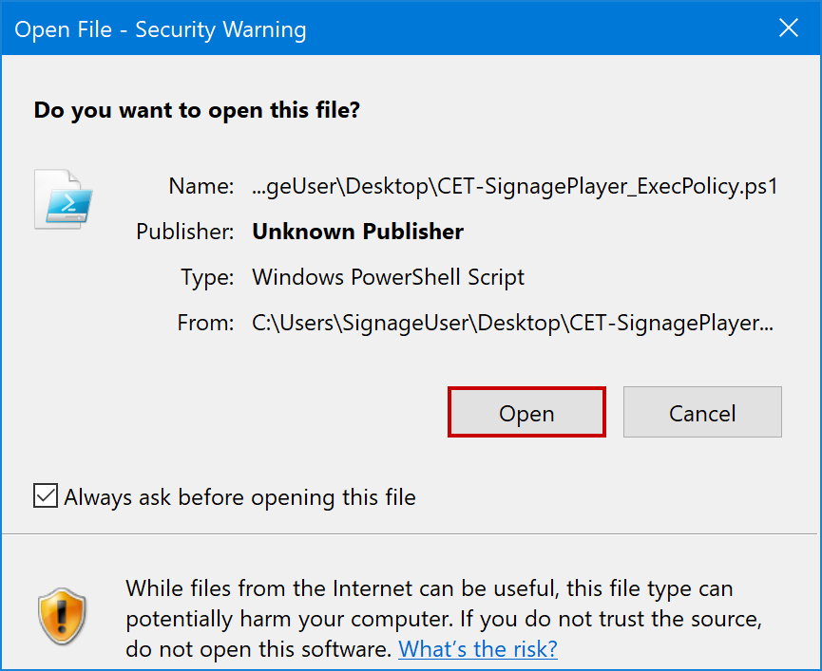

### Restart the PC

## Content Manager Configuration

The Four Winds Content Manager application is software that enables signage creation as well as remote management and monitoring of the Content Players. These steps detail best practices for installing and configuring the application locally.

### Install the Content Manager application

1. Download the Install .zip file [from here](https://ctexp-web01-signage.westus.cloudapp.azure.com/media/files/CET-PlayerInstall/FWI-ContentManager_Install.zip)
2. Extract the .exe file from the zip archive

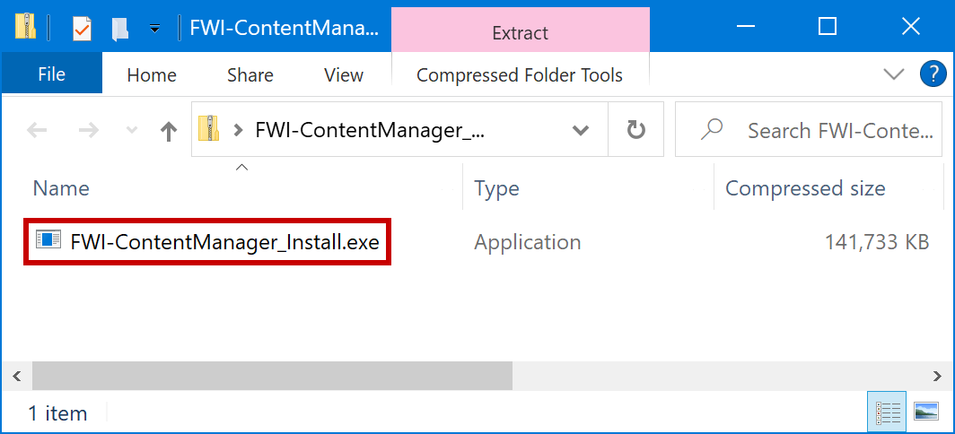

1. Launch the .exe file and select “Install” at the Welcome window

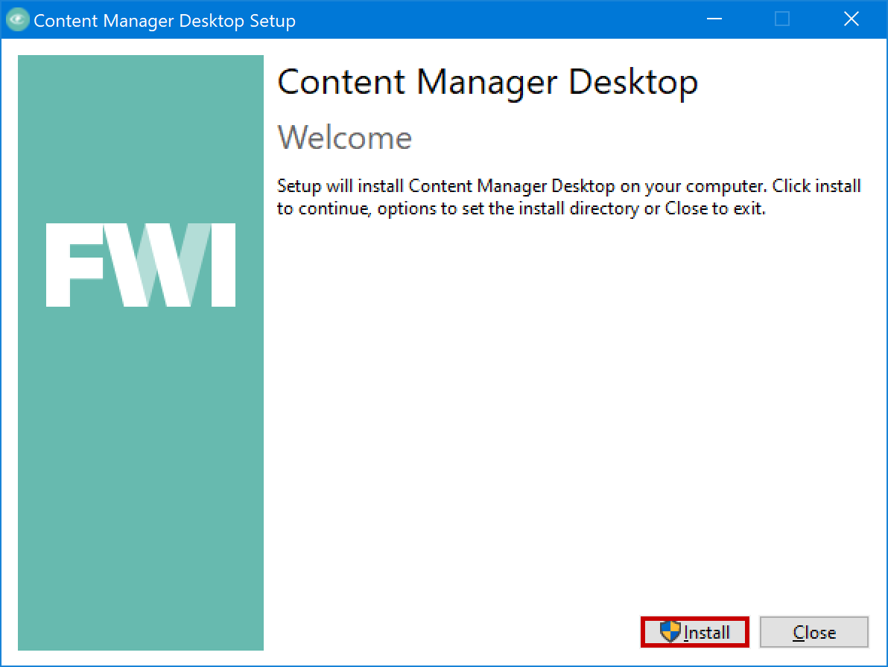

1. Select “Next” at the Setup Wizard window

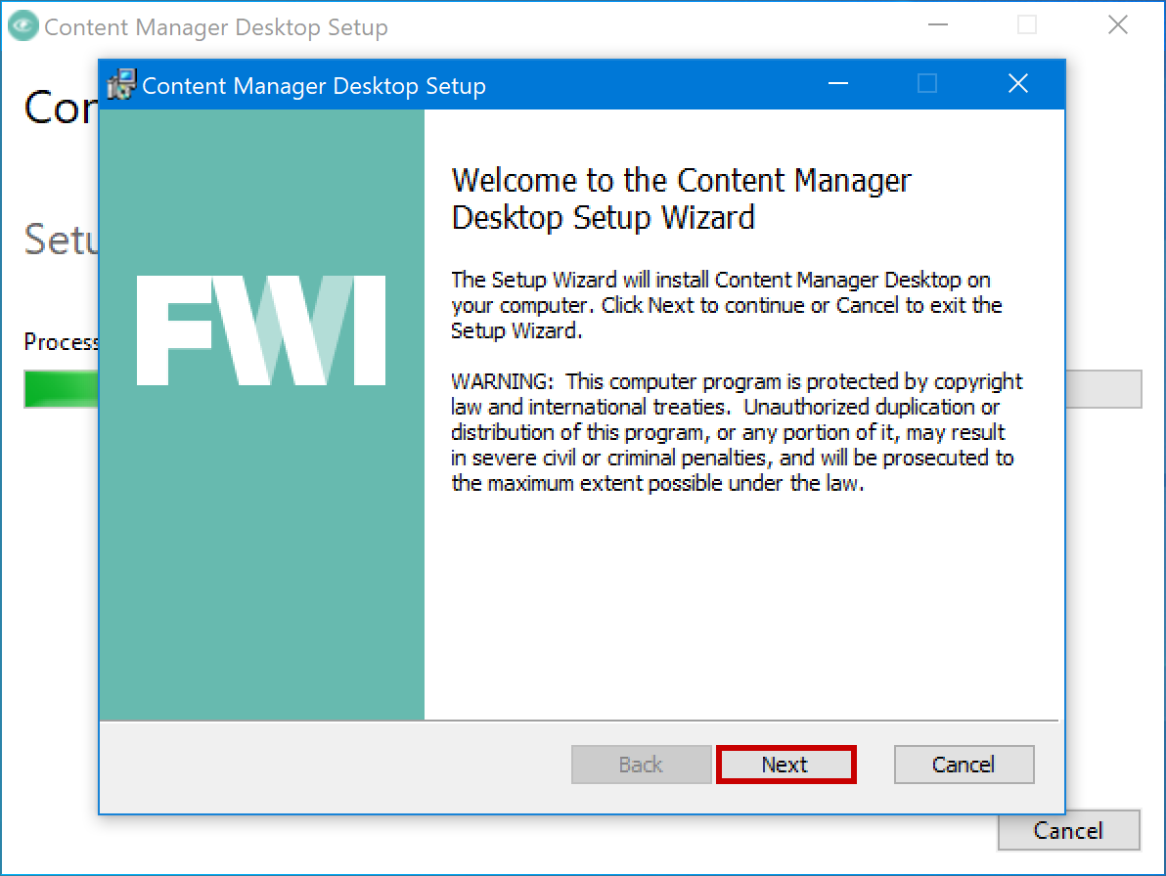

1. Select “Next” at the Destination Folder window

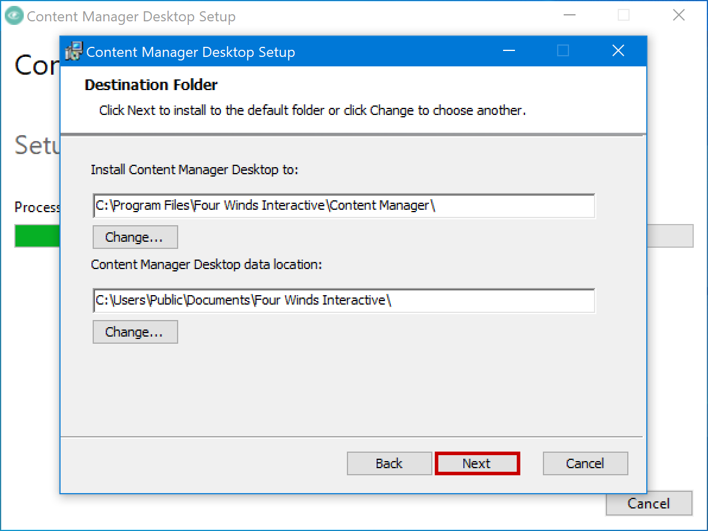

1. Select “Install” at the Ready to Install window

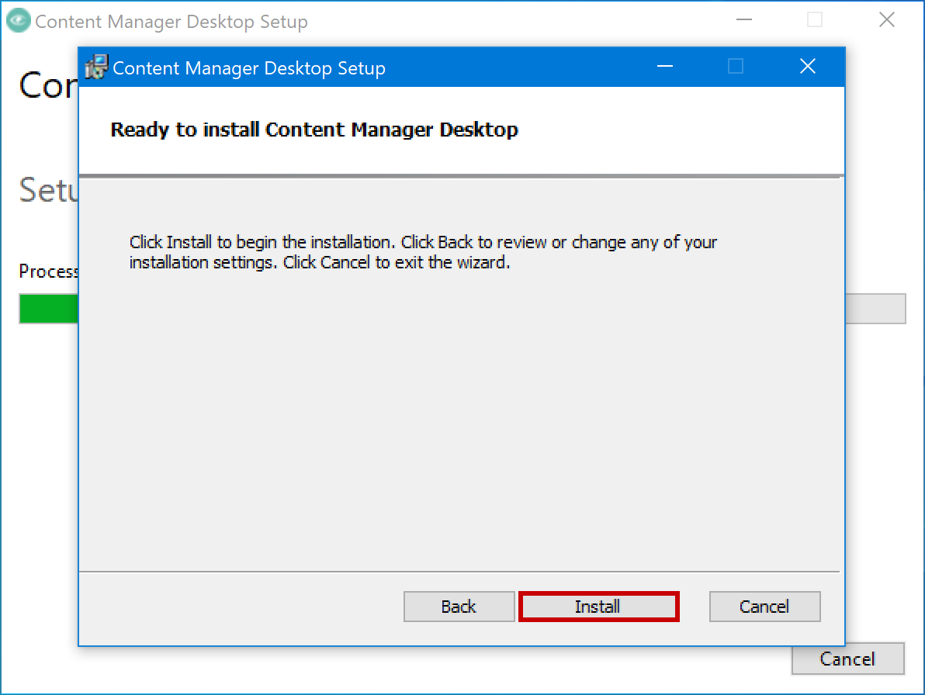

1. Click “Close” at the Setup Successful window

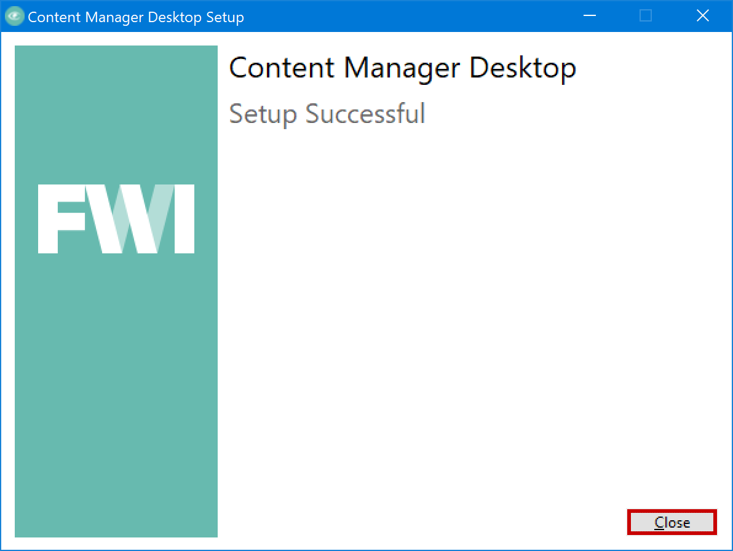

### Connecting Content Manager to the CET environment

1. Once you receive the FWI Cloud welcome email, click “Create Password”.

1. At the registration page enter your desired password, choose a ‘forgot password’ question, and provide the accompanying answer. Then select “Create My Account”.

1. At login page enter the email address (Username) associated with the new account and click “Next”.

1. On the login screen enter the password you previously created and click “Sign In”.

1. If the login is successful you should see the FWI Cloud dashboard.

1. Open CMD: Start à Four Winds Interactive à Content Manager Desktop

1. Select ‘File’ à “Open”

1. Select ‘New’ à “Hosted Connection…”

1. Enter the **connection details** and click “Test”.

CM Web Services URL: **https://ctexp-web01-signage.westus.cloudapp.azure.com/cmweb**

Remote Connection Name: **CTECloud**

1. Once connection is established click “OK” at the succeeded prompt and “OK” at Connection Properties window

1. Expand the new connection and highlight the “Microsoft-CEC” database, then Click “Open”.Graphical user interface, text, application

   Description automatically generated
2. In the dialog box, enter the email address associated with your new account, then click “Next”.

1. At the login screen enter the password associated with your new account, then click “Sign In.”Graphical user interface, application

   Description automatically generated
2. If the login is successful you should see the main CMD environment interface.

## Content Repository Configuration

Content items in the CET environment reference raw assets (Images, Videos, Data files, etc.) that are hosted in our Azure repository. This is so the content players have remote access to all necessary files within their deployments. The steps below detail how to view, access, and upload assets to this repository.

### View/Access the content repository

1. The repository can be viewed [from here](https://ctexp-web01-signage.westus.cloudapp.azure.com/media/files/). You may want to bookmark this page for easy access.

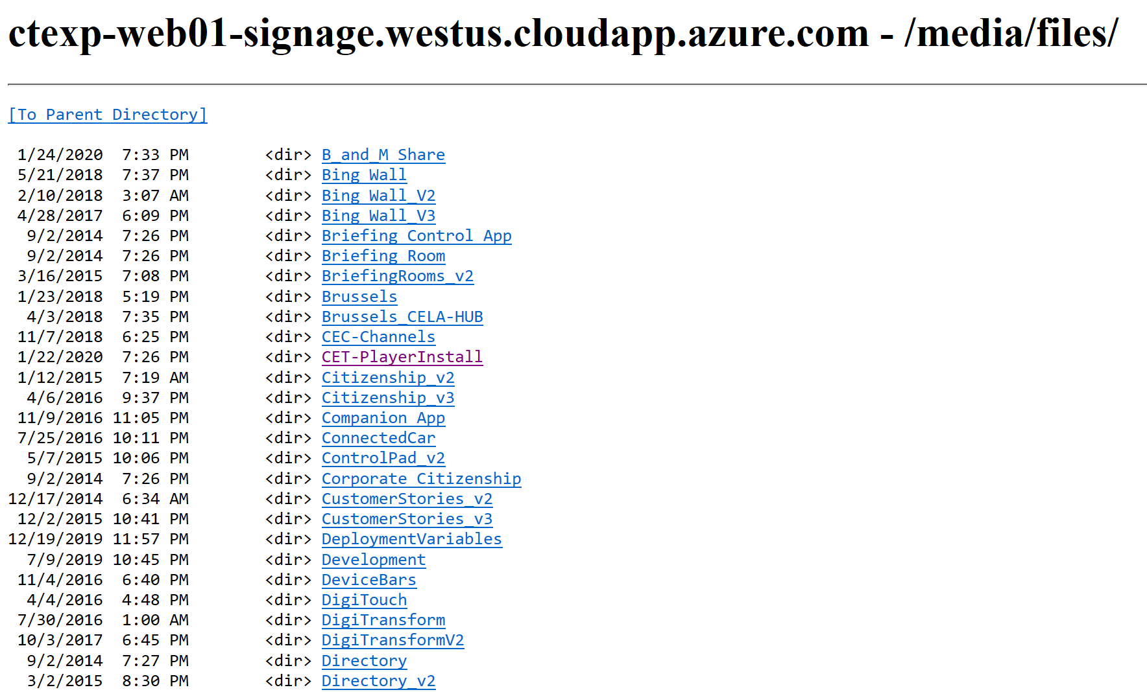

1. To access a file for reference in Content Manager, navigate to the desired file
   1. Right-Click à “Copy link”

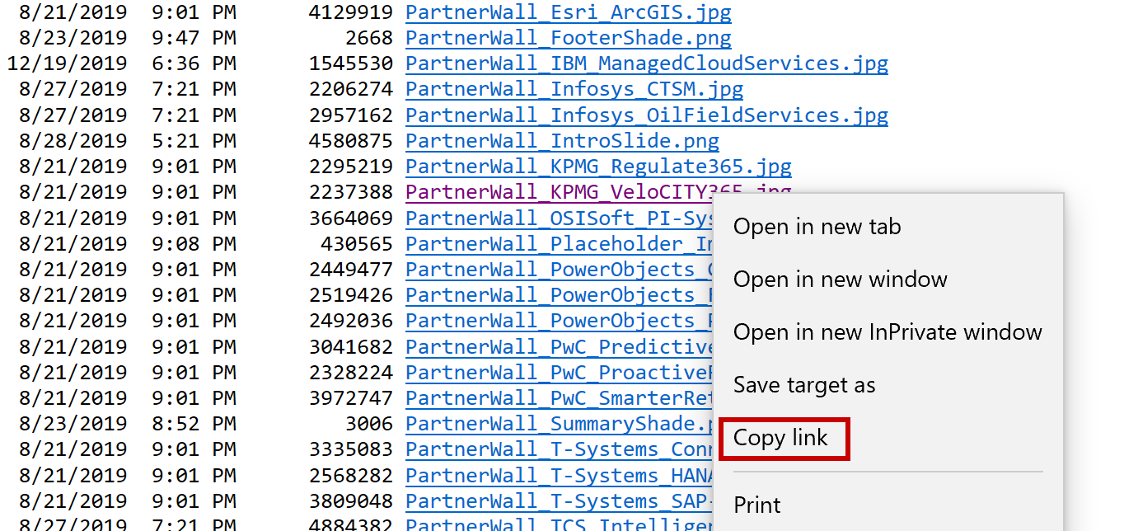

* 1. In content manager paste the URL into the Dynamic URL “Path” field of the content item

**Note:** It is recommended to set the deployment behavior to “Let player download this resource and check for updates” to reduce deployment file sizes.

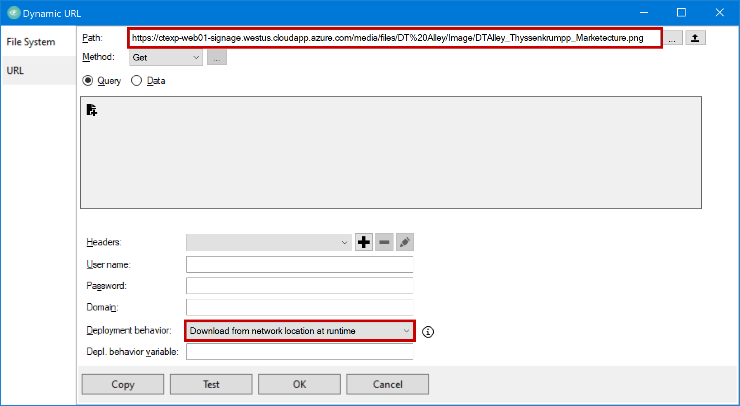

* 1. Click “OK”

### Installing the FileZilla FTP client

1. Download the Install .zip file [from here](https://ctexp-web01-signage.westus.cloudapp.azure.com/media/files/CET-PlayerInstall/FZ_Client_3.52.0_Install.zip)
2. Extract the .exe file from the zip archive

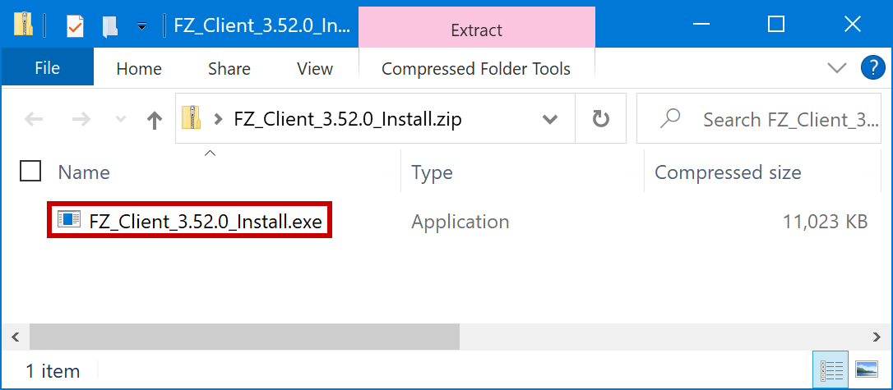

1. Launch the .exe file and select “I agree” at the License Agreement window

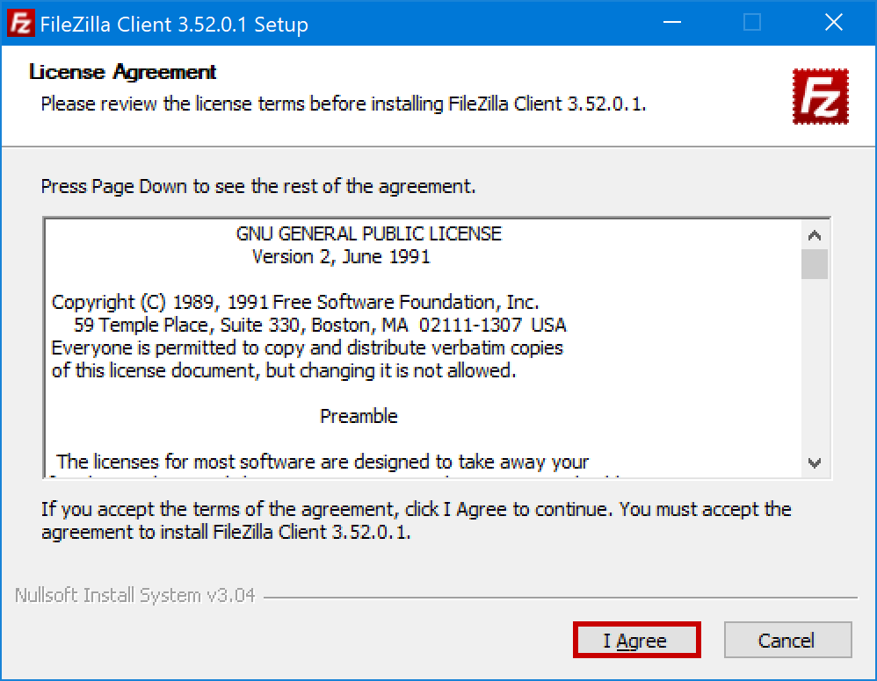

1. Select “Next” at the Installation Options window

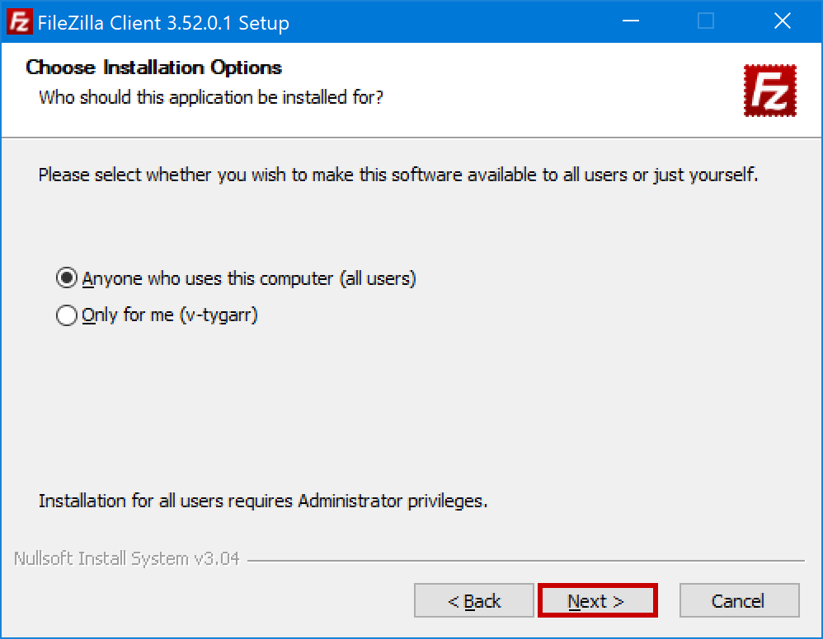

1. Select “Next” at the Choose Components window

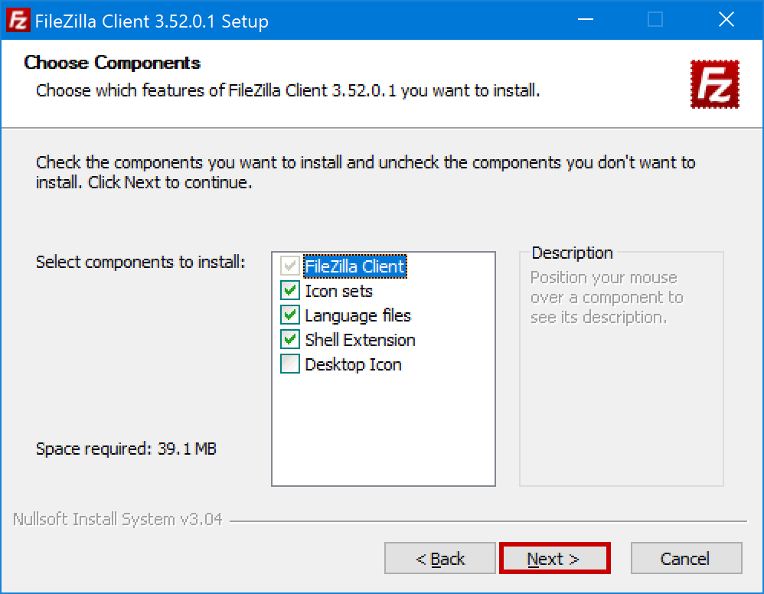

1. Select “Next” at the Install Location window

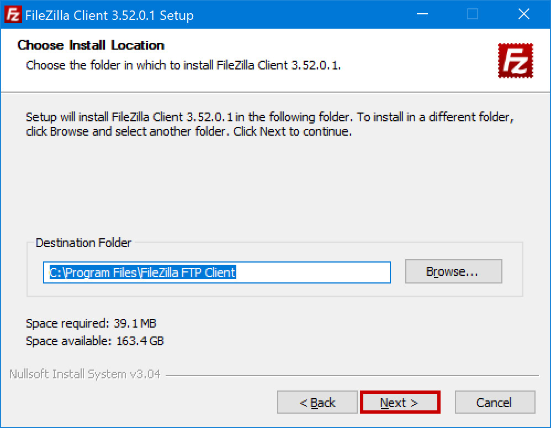

1. Select “Install” at the Menu Folder window

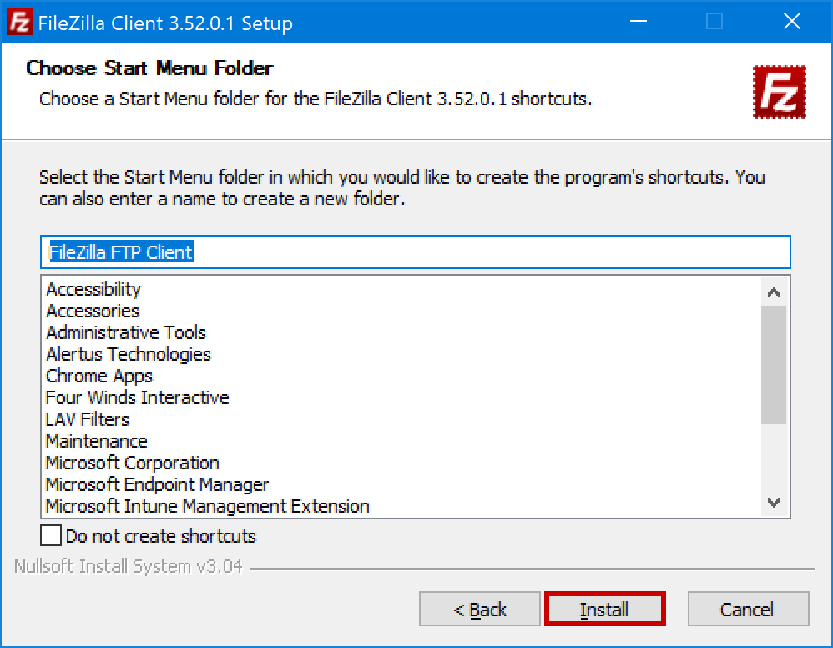

1. Choose “Finish” at the completing installation window

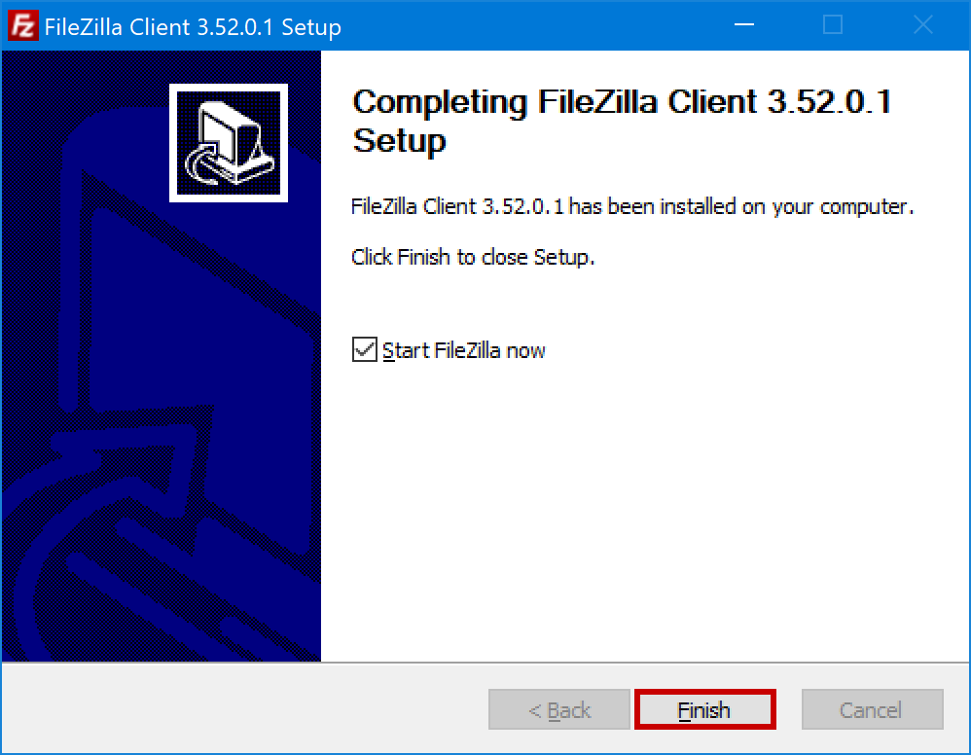

### Configuring FTP client for uploading to the repository

1. Start à FileZilla FTP Client à FileZilla

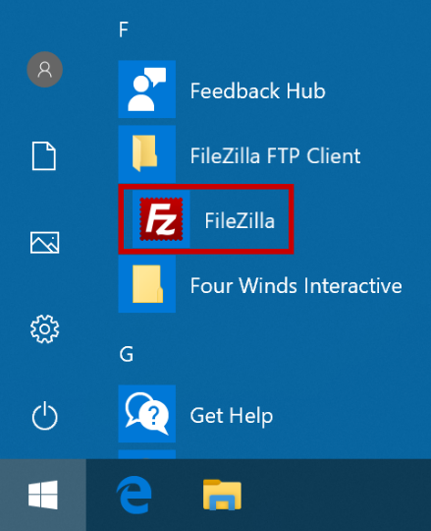

1. Open the “View” flyout menu and Uncheck the “Message log”, “Local directory tree”, Remote directory tree” and “Transfer queue” options

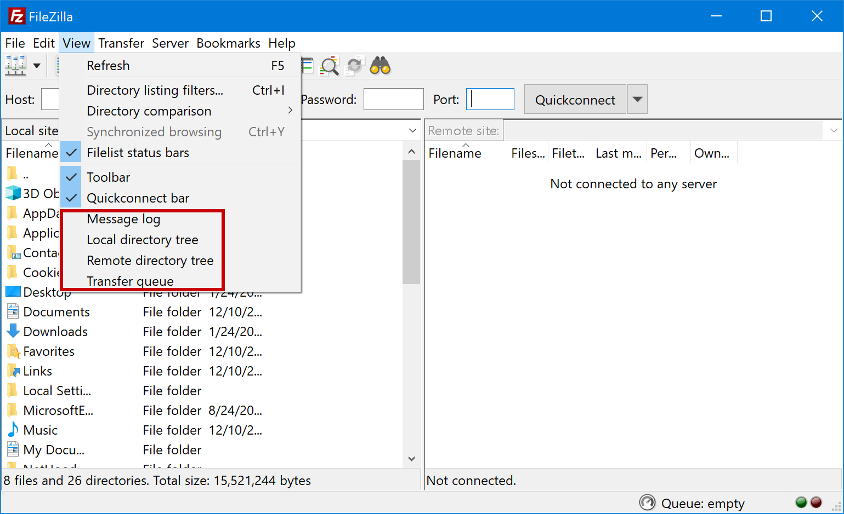

1. In the connect bar, enter the server credentials [found here](https://ctexp-web01-signage.westus.cloudapp.azure.com/media/files/CET-PlayerInstall/FZ_Repository_Credentials.txt), then select “Quickconnect”

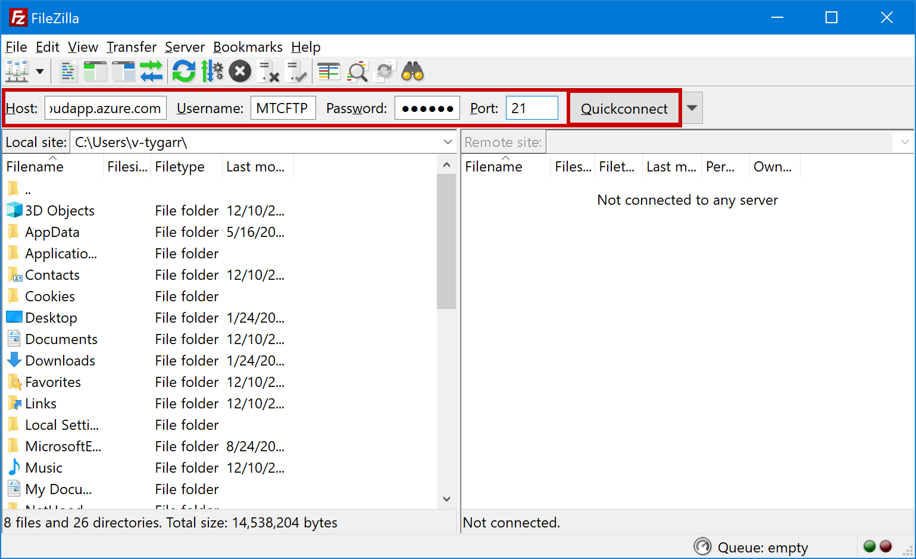

1. Select “OK” at the Remember passwords window

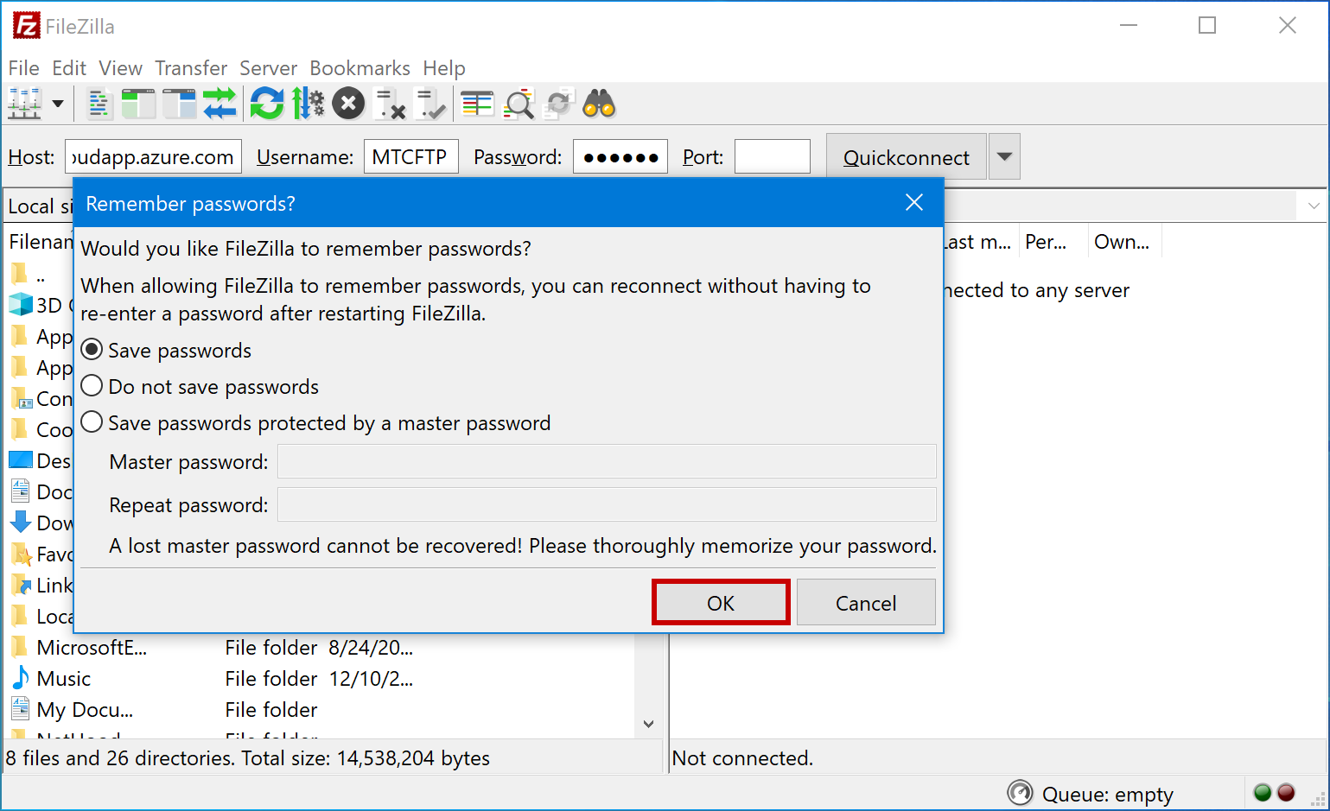

1. Select “OK” at the Unknown certificate window

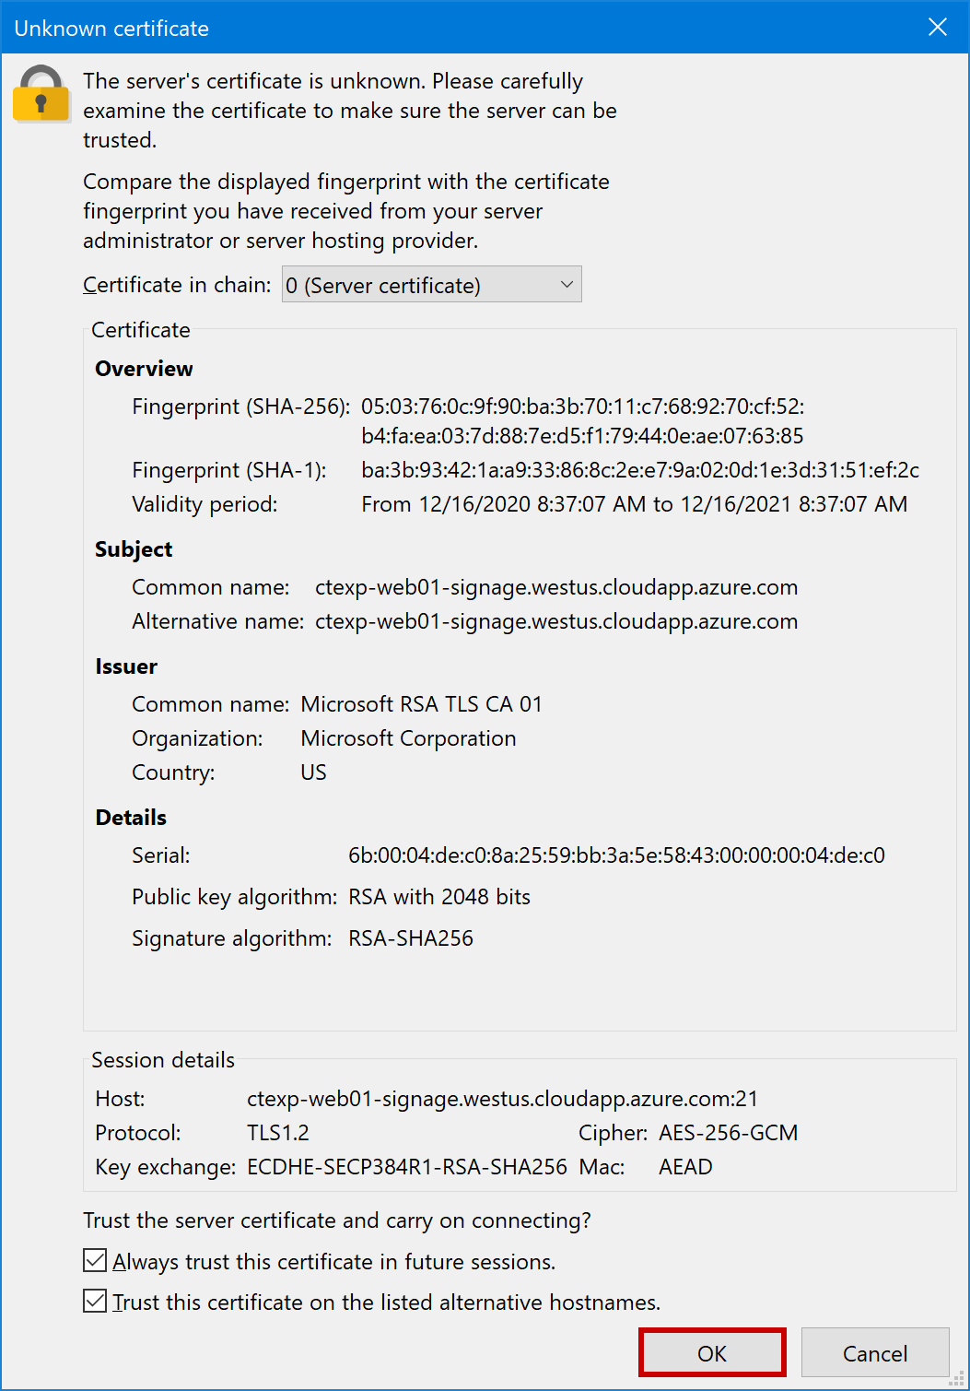

1. Once connected, navigate to your location’s corresponding directory

**Note:** Please add files and folders under the appropriate location to prevent conflicts. If

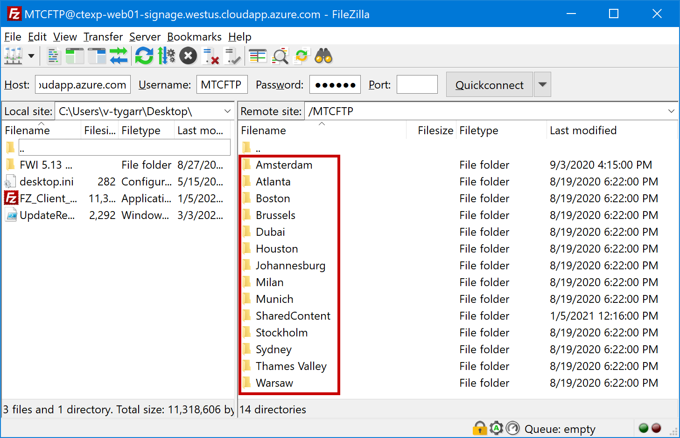

1. To upload new items, navigate the “Local site” pane (Left) and drag selected files to the “Remote site” pane (Right), or simply drop files and folders directly from Windows explorer.

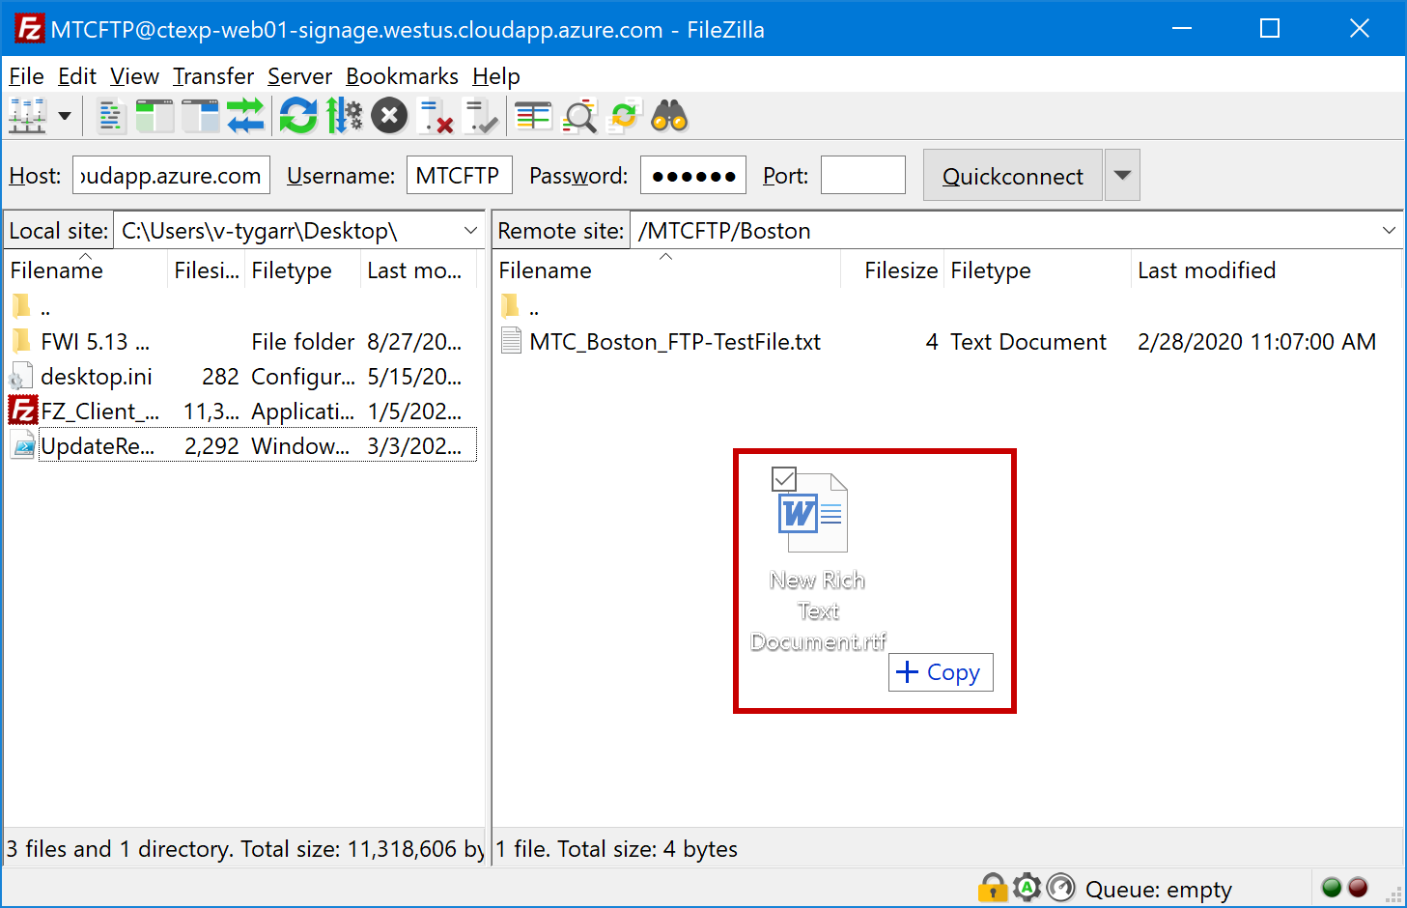

1. New Files/Folders can be found under the “MTCREPO” directory in the content repository:

<https://ctexp-web01-signage.westus.cloudapp.azure.com/media/files/MTCREPO/>